**Christmas Eve**

**Lessons & Carols**

**December 24, 2023 7:00 p.m.**

**Good Shepherd Lutheran Church**

1221 LaGrange Ave, Tomah, WI 54660 Phone (608)374-2444

Pastor: Noah J. Rogness T pastor.rogness@goodsheptomah.com

Visit our web site @ www.goodsheptomah.weebly.com

Lutheran Church-Missouri Synod

**Visitor Information:** Welcome to Good Shepherd, we are glad you are joining us for worship! If you need help following along with the hymnal and the order of worship, please sit close to a member and ask questions. The ushers in the back of the sanctuary are also here to assist you in any way they can. The Nursery located at the left of the sanctuary entrance is reserved for nursing mothers.

**Theme for Christmas Eve:** On this night, the Church gathers in vigil anticipating the birth of Jesus. Familiar carols resound during the service, which concludes with only handheld candles illuminating the expectant sanctuary.

**_____________________________________________________________________________**

Prelude

*Stand and face the processional cross.*

Once in Royal David's City *LSB 376*

5 Not in that poor, lowly stable  
 With the oxen standing by  
Shall we see Him, but in heaven,  
 Set at God’s right hand on high.  
Then like stars His children, crowned,  
All in white, His praise will sound!

Public domain

Bidding Prayer for Christmas Eve

L Beloved in Christ, be it this Christmas Eve our care and delight to prepare ourselves to hear again the message of the angels; in heart and mind to go even unto Bethlehem and see this thing which is come to pass, and the Babe lying in a manger.  
  
Let us read and mark in Holy Scripture the tale of the loving purposes of God from the first days of our disobedience unto the glorious Redemption brought us by this Holy Child; and let us make this Church, glad with our carols of praise:  
  
But first let us pray for the needs of His whole world; for peace and goodwill over all the earth; for unity in truth and love within the Church he came to build, and especially within the churches of our Synod. Let us also pray for Joseph our president, Tony our governor, and for all who hold the authority in this and every land.  
  
And because this of all things would rejoice His heart,

let us at this time remember in His name the poor and the helpless, the cold, the hungry and the oppressed; the sick in body and in mind and them that mourn; the lonely and the unloved; the aged and the little children; all who know not the Lord Jesus, or who love him not, or who by sin have grieved His heart of love.  
  
Lastly let us remember before God His pure and lowly mother, and all those who rejoice with us, but upon another shore and in a greater light, that multitude which no man can number, whose hope was in the Word made flesh, and with whom, in this Lord Jesus, we for evermore are one.

These prayers and praises let us humbly offer up to the throne of heaven, in the words which Christ Himself hath taught us:

C **Our Father who art in heaven,**

**hallowed be Thy name,**

**Thy kingdom come,**

**Thy will be done on earth as it is in heaven;**

**give us this day our daily bread;**

**and forgive us our trespasses**

**as we forgive those who trespass against us;**

**and lead us not into temptation,**

**but deliver us from evil.**

**For Thine is the kingdom and the power and the glory**

**forever and ever. Amen.**

**Now Sing We, Now Rejoice** *LSB 386*

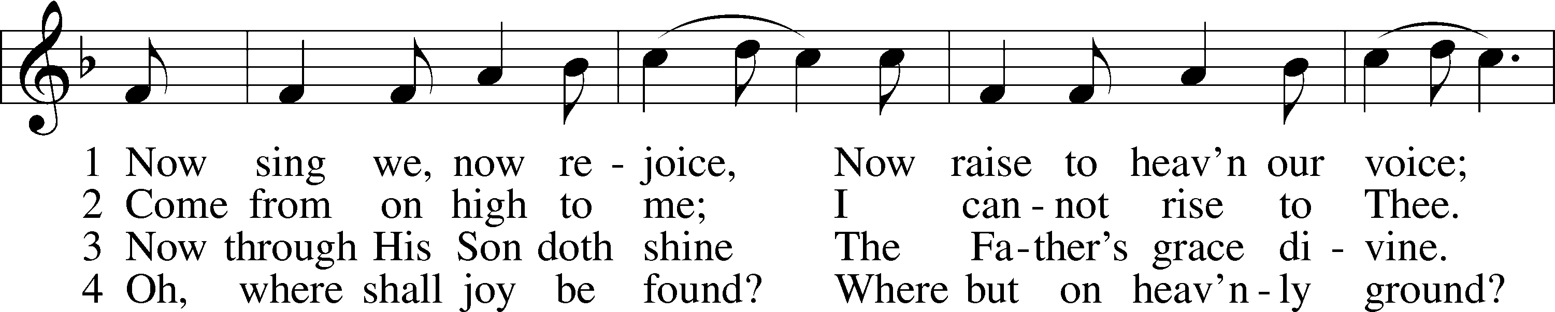

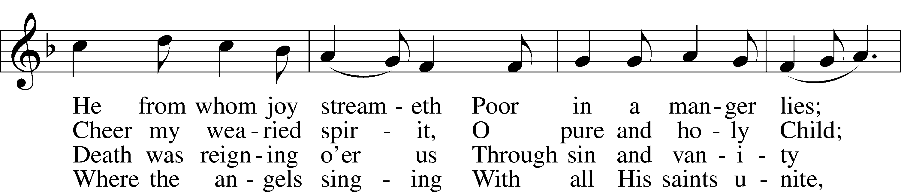

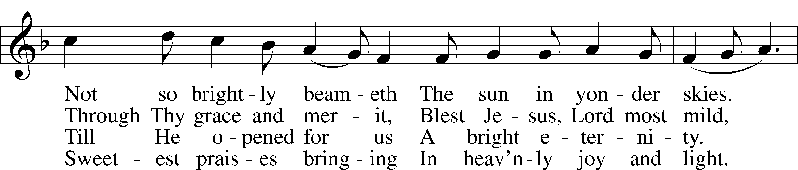

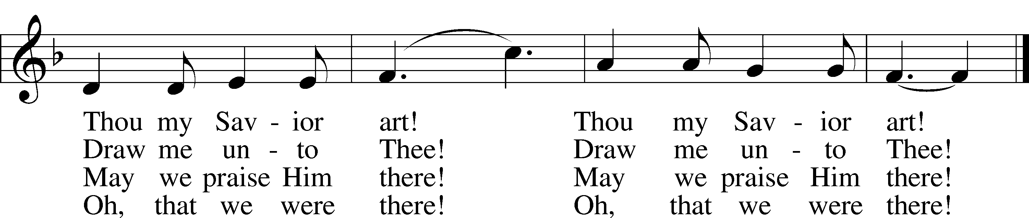

Text and tune: Public domain

*Sit*

Lesson  *Isaiah 7:10-14 (The Sign of Immanuel)*

Again the Lord spoke to Ahaz, “Ask a sign of the Lord your God; let it be deep as Sheol or high as heaven.” But Ahaz said, “I will not ask, and I will not put the Lord to the test.” And he said, “Hear then, O house of David! Is it too little for you to weary men, that you weary my God also? Therefore the Lord himself will give you a sign. Behold, the virgin shall conceive and bear a son, and shall call his name Immanuel.”

L O Lord, have mercy on us.

C **Thanks be to God.**

What Child Is This *LSB 370*

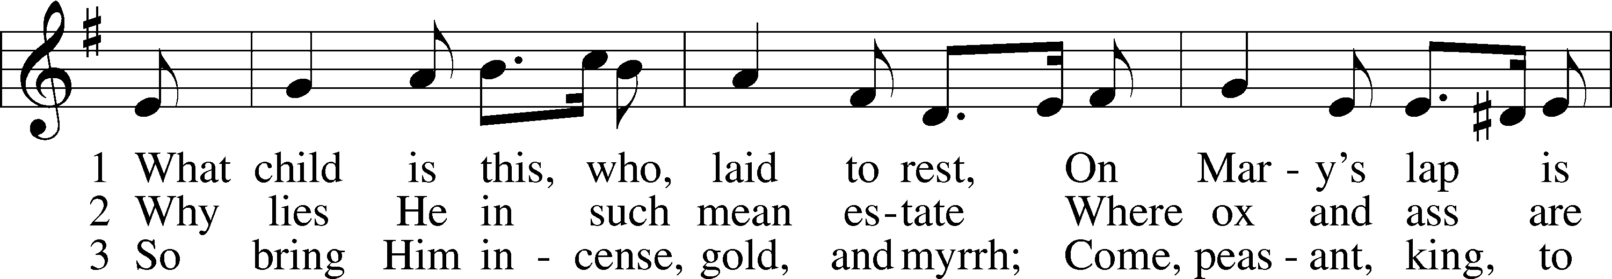

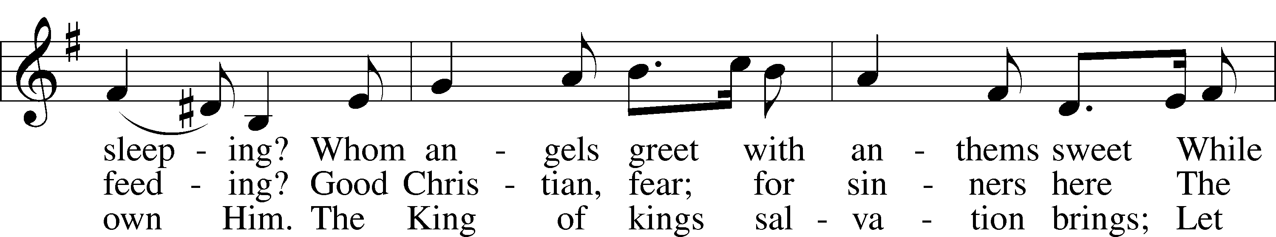

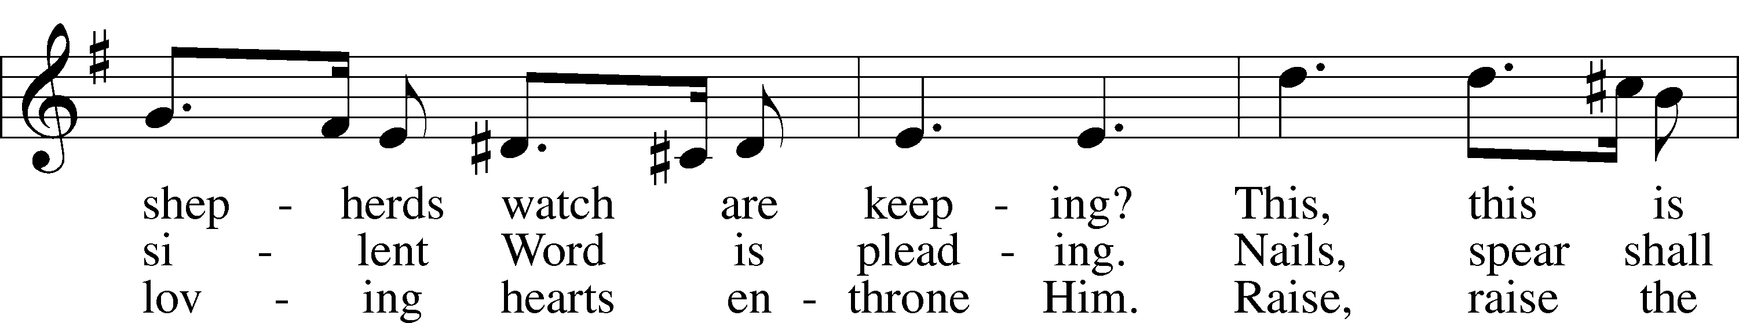

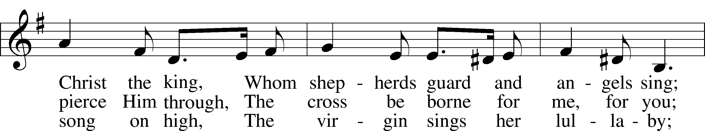

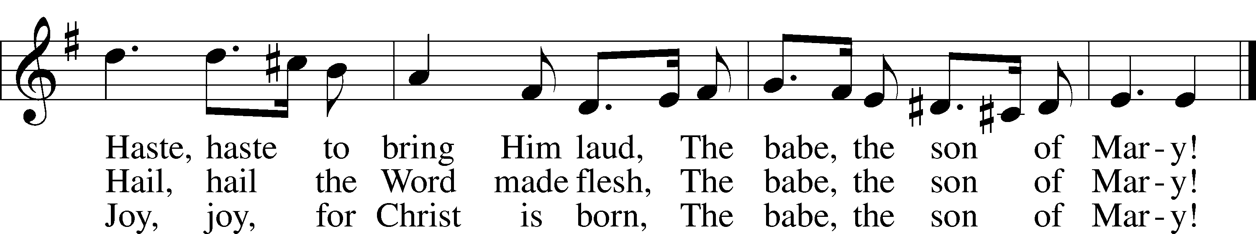

Text and tune: Public domain

Public domain

Lesson  *Isaiah 11:1–9 (The Spirit of the Lord rests upon the Messiah)*

There shall come forth a shoot from the stump of Jesse, and a branch from his roots shall bear fruit. And the Spirit of the Lord shall rest upon him,

the Spirit of wisdom and understanding, the Spirit of counsel and might,

the Spirit of knowledge and the fear of the Lord. And his delight shall be in the fear of the Lord. He shall not judge by what his eyes see, or decide disputes by what his ears hear, but with righteousness he shall judge the poor, and decide with equity for the meek of the earth; and he shall strike the earth with the rod of his mouth, and with the breath of his lips he shall kill the wicked. Righteousness shall be the belt of his waist, and faithfulness the belt of his loins. The wolf shall dwell with the lamb, and the leopard shall lie down with the young goat, and the calf and the lion and the fattened calf together; and a little child shall lead them. The cow and the bear shall graze; their young shall lie down together; and the lion shall eat straw like the ox. The nursing child shall play over the hole of the cobra, and the weaned child shall put his hand on the adder’s den. They shall not hurt or destroy in all my holy mountain; for the earth shall be full of the knowledge of the Lord as the waters cover the sea.

L O Lord, have mercy on us.

C **Thanks be to God.**

Away in a Manger *(Sunday School Choir)* *LSB 364*

Lesson  *Micah 5:2–5a (The Savior will be born in Bethlehem)*

But you, O Bethlehem Ephrathah, who are too little to be among the clans of Judah, from you shall come forth for me one who is to be ruler in Israel, whose origin is from of old, from ancient days. Therefore he shall give them up until the time when she who is in labor has given birth; then the rest of his brothers shall return to the people of Israel. And he shall stand and shepherd his flock in the strength of the Lord, in the majesty of the name of the Lord his God. And they shall dwell secure, for now he shall be great to the ends of the earth. And he shall be their peace.

L O Lord, have mercy on us.

C **Thanks be to God.**

O Little Town of Bethlehem *LSB 361*

Public domain

Lesson *Luke 1:26–38 (Gabriel announces the Savior to Mary)*

In the sixth month the angel Gabriel was sent from God to a city of Galilee named Nazareth, to a virgin betrothed to a man whose name was Joseph,

of the house of David. And the virgin’s name was Mary. And he came to her and said, “Greetings, O favored one, the Lord is with you!” But she was greatly troubled at the saying, and tried to discern what sort of greeting this might be. And the angel said to her, “Do not be afraid, Mary, for you have found favor with God. And behold, you will conceive in your womb and bear a son, and you shall call his name Jesus. He will be great and will be called the Son of the Most High. And the Lord God will give to him the throne of his father David, and he will reign over the house of Jacob forever, and of his kingdom there will be no end.”

And Mary said to the angel, “How will this be, since I am a virgin?”

And the angel answered her, “The Holy Spirit will come upon you, and the power of the Most High will overshadow you; therefore the child to be born will be called holy—the Son of God.

And behold, your relative Elizabeth in her old age has also conceived a son, and this is the sixth month with her who was called barren. For nothing will be impossible with God.” And Mary said, “Behold, I am the servant of the Lord; let it be to me according to your word.” And the angel departed from her.

L O Lord, have mercy on us.

C **Thanks be to God.**

From Heaven Above to Earth I Come, sts. 1-3 *LSB 356*

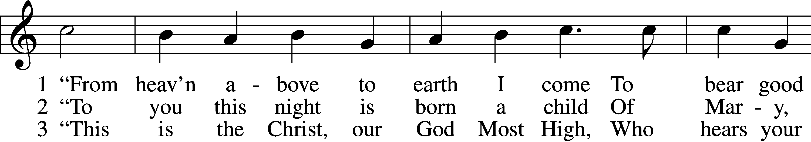

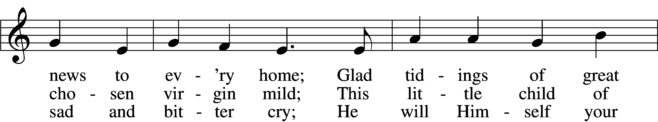

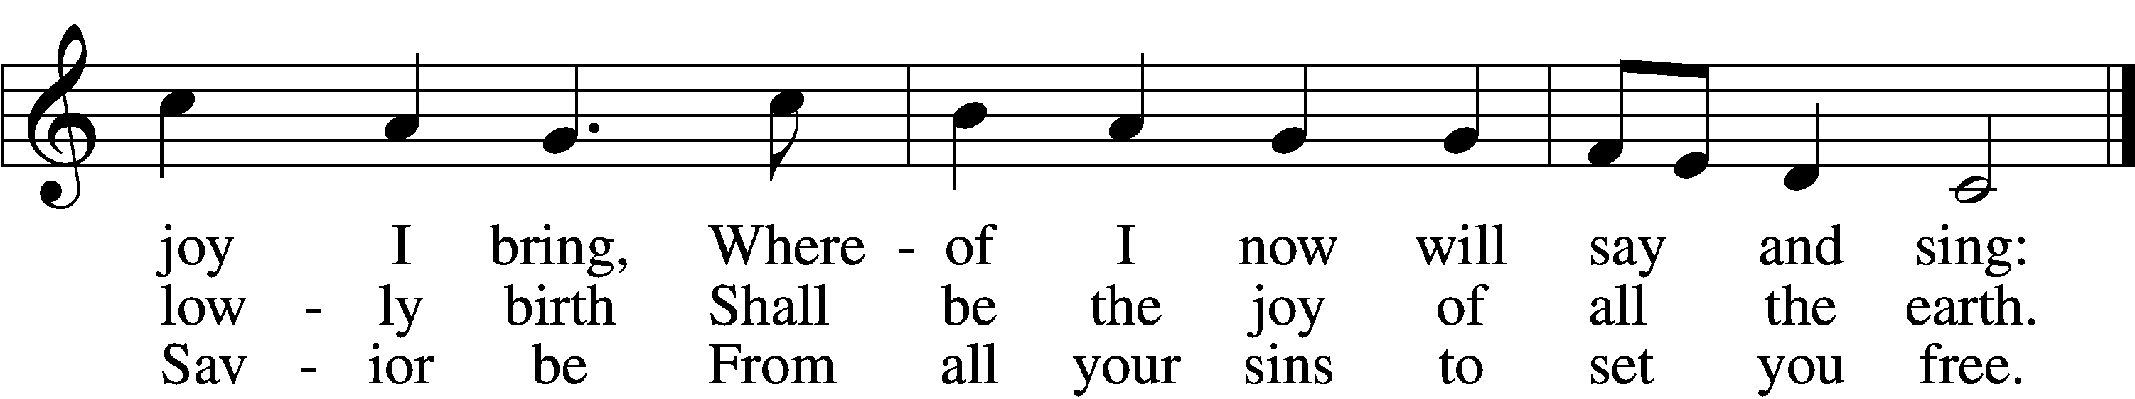

Text and tune: Public domain

*Stand*

Lesson  *Luke 2:1–16 (The birth of Jesus)*

And it came to pass in those days that a decree went out from Caesar Augustus that all the world should be registered. This census first took place while Quirinius was governing Syria. So all went to be registered, everyone to his own city.

Joseph also went up from Galilee, out of the city of Nazareth, into Judea, to the city of David, which is called Bethlehem, because he was of the house and lineage of David, to be registered with Mary, his betrothed wife,who was with child. So it was, that while they were there, the days were completed for her to be delivered.

And she brought forth her firstborn Son, and wrapped Him in swaddling cloths, and laid Him in a manger, because there was no room for them in the inn.

Now there were in the same country shepherds living out in the fields, keeping watch over their flock by night. And behold, an angel of the Lord stood before them, and the glory of the Lord shone around them, and they were greatly afraid. Then the angel said to them, “Do not be afraid,

for behold, I bring you good tidings of great joy which will be to all people. For there is born to you this day in the city of David a Savior, who is Christ the Lord. And this will be the sign to you: You will find a Babe wrapped in swaddling cloths, lying in a manger.”

And suddenly there was with the angel a multitude of the heavenly host praising God and saying: “Glory to God in the highest, And on earth peace, goodwill toward men!”

So it was, when the angels had gone away from them into heaven, that the shepherds said to one another, “Let us now go to Bethlehem and see this thing that has come to pass, which the Lord has made known to us.”

And they came with haste and found Mary and Joseph, and the Babe lying in a manger. (NKJV)

L O Lord, have mercy on us.

C **Thanks be to God.**



Hark! The Herald Angels Sing *LSB 380*

Public domain

*Sit*

Sermon

Offering

*“Gesu Bambino” by Pietro Yon; arr. by Richard Walters*

*During the Offering, please sign the “Record of Fellowship” (maroon pad) located in the pew near the center*

*aisle and pass it to your neighbor.*

# *The congregation stands while the candles are lit, and the lights are extinguished.*

# **Collects for Christmas Eve**

L O God, You make us glad with the yearly remembrance of the birth of Your only-begotten Son, Jesus Christ. Grant that as we joyfully receive Him as our Redeemer, we may with sure confidence behold Him when He comes to be our Judge; through the same Jesus Christ, our Lord, who lives and reigns with You and the Holy Spirit, one God, now and forever.

C **Amen.**

L Lord God, heavenly Father, we give thanks to You that of Your mercy and compassion You caused Your Son to become incarnate, and through Him redeemed us from sin and everlasting death: We beseech You, enlighten our hearts by Your Holy Spirit, that we may ever be thankful for such grace, and comfort ourselves thereby in all tribulation and temptation; through the same, Your beloved Son, Jesus Christ, our Lord.

C **Amen.**

# **Collect for Peace**

L O God, from whom come all holy desires, all good counsels, and all just works, give to us, Your servants, that peace which the world cannot give, that our hearts may be set to obey Your commandments and also that we, being defended from the fear of our enemies, may live in peace and quietness; through Jesus Christ, Your Son, our Lord, who lives and reigns with You and the Holy Spirit, one God, now and forever.

C **Amen.**

# **Benediction**

P The grace of the Lord T Jesus Christ and the love of God and the communion of the Holy Spirit be and abide with you always.

C **Amen.**

**Silent Night, Holy Night** *LSB 363*

Public domain

# *Closing postlude: Silent Night Arrangement by Roger Goetz*

# *Please extinguish candles as the bell chimes.*

Acknowledgments: Unless otherwise indicated, all scripture quotations are from *The Holy Bible, English Standard Version*, copyright © 2001 by Crossway Bibles, a division of Good News Publishers. Used by permission. All rights reserved. Created by Lutheran Service Builder © 2006 Concordia Publishing House.

**Serving Our Lord in His House Today:**

Pastor: Rev. Noah J. Rogness

Organist: Rebecca Moseley

Accompanist: Linda Ecker

Violinists: Amanda Keller & Leah Oakes

Soloist: Meredith Moseley

Elder: Dillin Lafferty

