**Third Sunday in Advent**

**Gaudete**

**December 17, 2023**

**Good Shepherd Lutheran Church**

1221 LaGrange Ave, Tomah, WI 54660 Phone (608)374-2444

Pastor: Noah J. Rogness T pastor.rogness@goodsheptomah.com

Visit our web site @ www.goodsheptomah.weebly.com

Lutheran Church-Missouri Synod

**Visitor Information:** Welcome to Good Shepherd, we are glad you are joining us for worship!

If you need help following along with the hymnal and the order of worship, please sit close to a member and ask questions. The ushers in the back of the sanctuary are also here to assist you in any way they can. The Nursery located at the left of the sanctuary entrance is reserved for nursing mothers.  Please join us for refreshments, Sunday School, and Bible Study in the Fellowship Hall at 10:15 a.m.

**Holy Communion:** According to God’s Word and in unity with Christ’s Church, Good Shepherd Lutheran Church practices closed communion. We do this not to offend, but because Scripture teaches that those communing together should be completely unified in their confession of the Faith. In this Sacrament we are not only joined to Christ our Head who is present in His body and blood, but are also knit together with one another as His Body, in which there should be no division of belief. We would love to see you join our congregation and communion.

If you are interested in becoming a member or have questions or concerns about this Biblical doctrine, please speak with the Pastor.

**Theme for the Third Week in Advent:** The voice of the Baptizer cried out in the wilderness:

"Prepare the way of the Lord . . ." (Isa. 40:1). John called the people to be made ready for the Messiah's coming through repentance, for "all flesh is grass" (Isa. 40:6). Now He asks from prison, "Are you the one who is to come . . .?" (Matt. 11:2). Jesus' works bear witness that He is. The sick are made well; the dead are raised, and the poor have the Gospel preached to them. Their iniquity is pardoned; they have received from the Lord's hand double forgiveness for all their sins. The "stewards of the mysteries of God" (1 Cor. 4:1) still deliver Christ's overflowing forgiveness to the poor in spirit, comforting God's people with the word of the Gospel which stands forever. This Gospel produces rejoicing among all those who believe . ______________________________________________________________________________________

# **Pre-Service Music & Welcome**

**Divine Service Setting One – (LSB) 151**

Arise, O Christian People LSB 354

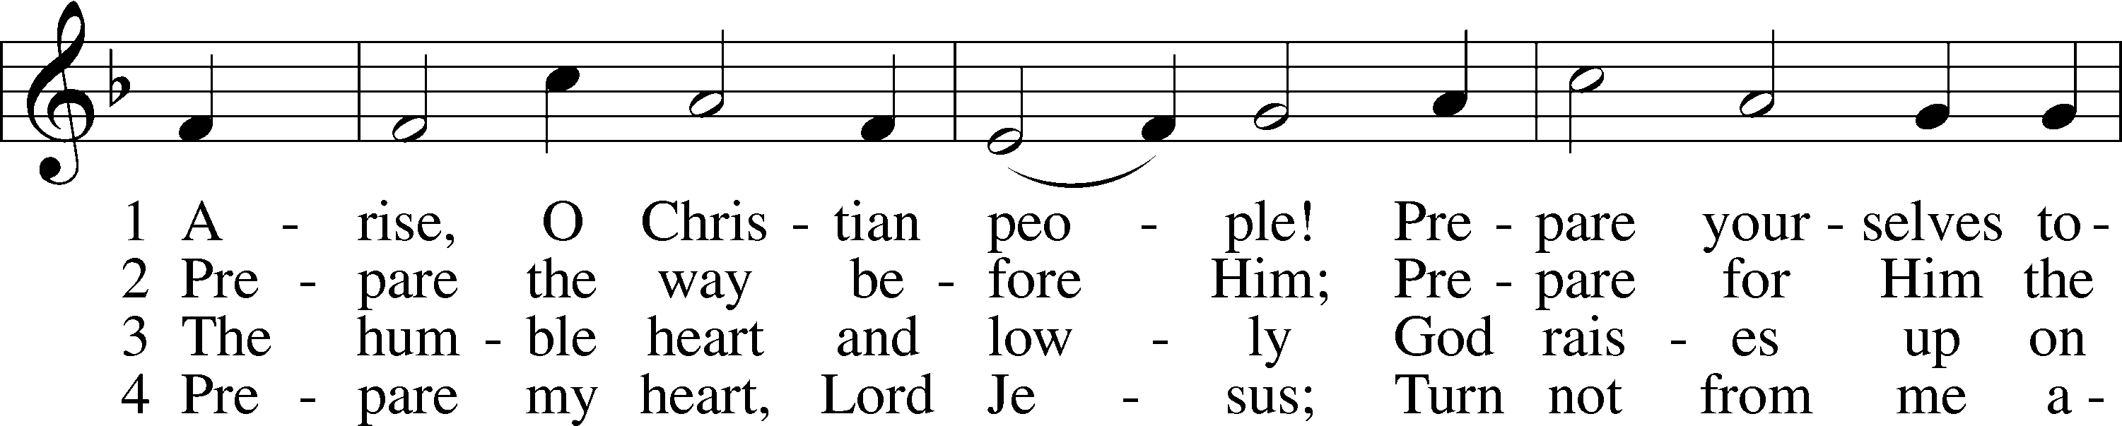

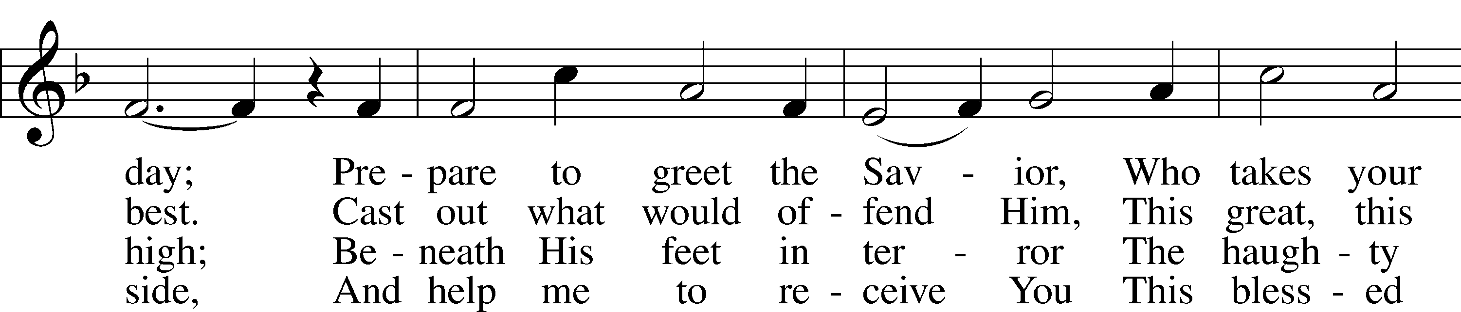

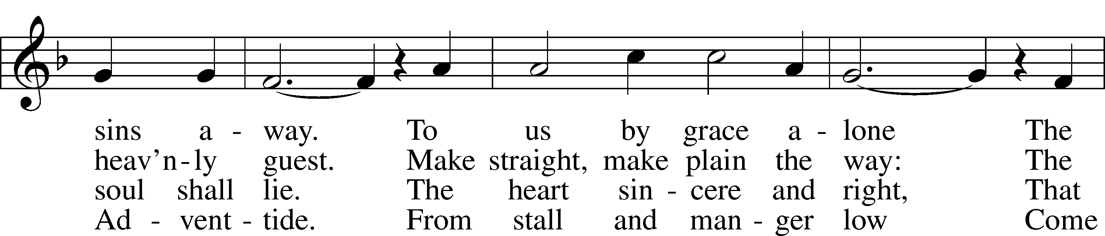

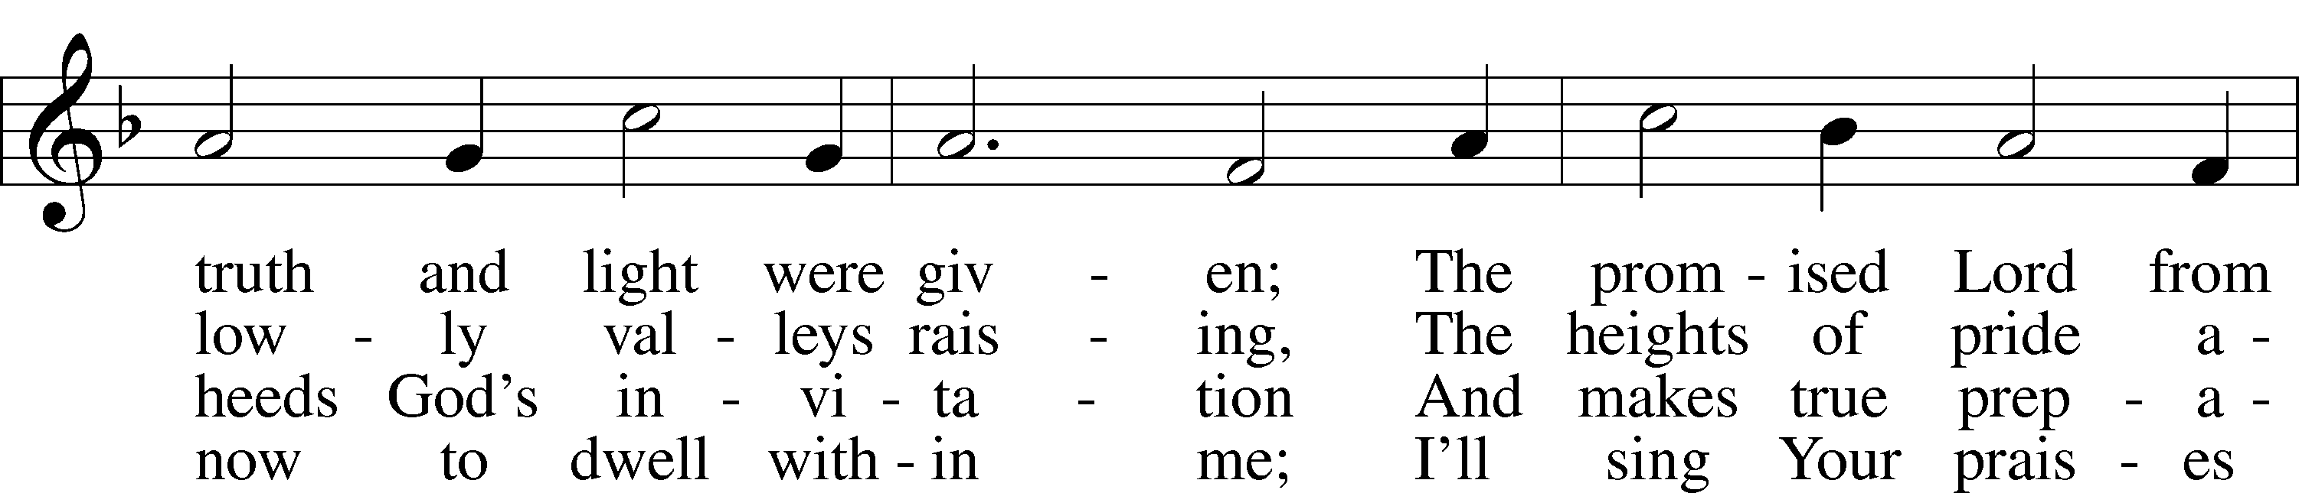

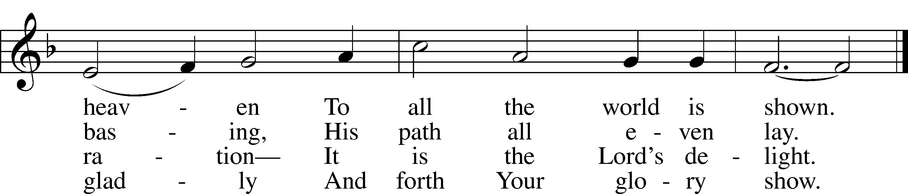

Text: Valentin Thilo, 1607–62; tr. Arthur T. Russell, 1806–74, alt.  
Tune: New Catechismus Gesangbüchlein, 1598, Hamburg, alt.  
Text and tune: Public domain

Stand

# Confession and Absolution

The sign of the cross may be made by all in remembrance of their Baptism.

Invocation

P In the name of the Father and of the T Son and of the Holy Spirit.

C **Amen.**

Exhortation LSB 151

P If we say we have no sin, we deceive ourselves, and the truth is not in us.

C **But if we confess our sins, God, who is faithful and just, will forgive our sins and cleanse us from all unrighteousness.**

Silence for reflection on God’s Word and for self-examination.

Confession of Sins LSB 151

P Let us then confess our sins to God our Father.

C **Most merciful God, we confess that we are by nature sinful and unclean. We have sinned against You in thought, word, and deed, by what we have done and by what we have left undone. We have not loved You with our whole heart; we have not loved our neighbors as ourselves. We justly deserve Your present and eternal punishment. For the sake of Your Son, Jesus Christ, have mercy on us. Forgive us, renew us, and lead us, so that we may delight in Your will and walk in Your ways to the glory of Your holy name. Amen.**

Absolution LSB 151

P Almighty God in His mercy has given His Son to die for you and for His sake forgives you all your sins. As a called and ordained servant of Christ, and by His authority, I therefore forgive you all your sins in the name of the Father and of the T Son and of the Holy Spirit.

C **Amen.**

# Service of the Word

Introit Psalm 85:1–2, 6, 8; antiphon: Philippians 4:4–5

***Antiphon***

Rejoice in the Lord always;  
 again I will say, Rejoice.  
Let your reasonableness be known to everyone.  
 The Lord is at hand.

Lord, you were favorable to your land;  
 you restored the fortunes of Jacob.

**You forgave the iniquity of your people;  
 you covered all their sin.**  
Will you not revive us again,  
 that your people may rejoice in you?  
**Let me hear what God the Lord will speak,  
 for he will speak peace to his people, to his saints; but let them not turn back to folly.**  
**Glory be to the Father and to the Son**  
 **and to the Holy Spirit;**  
**as it was in the beginning,**  
 **is now, and will be forever. Amen.**  
Rejoice in the Lord always;  
 again I will say, Rejoice.  
Let your reasonableness be known to everyone.  
 The Lord is at hand.

Kyrie LSB 152

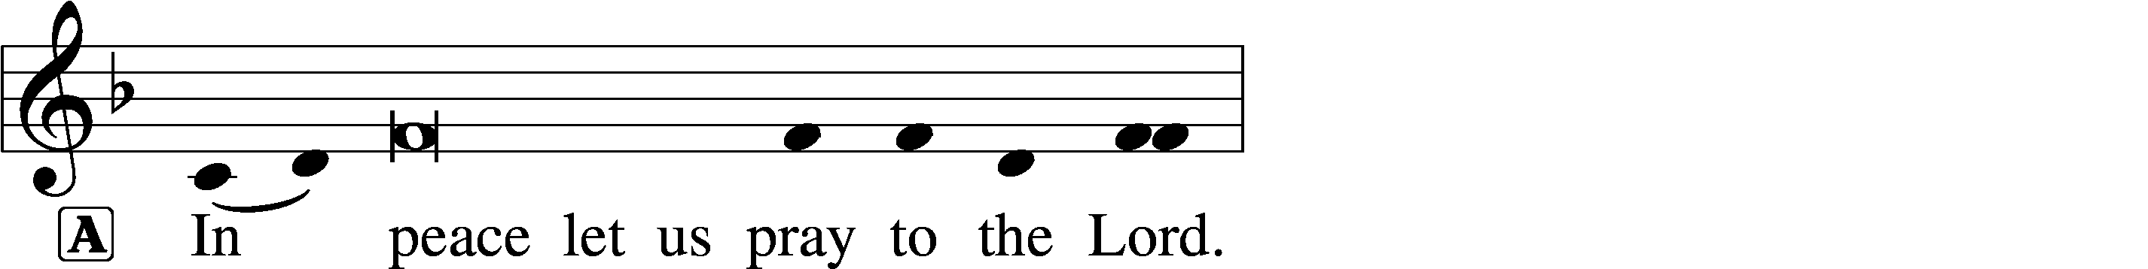

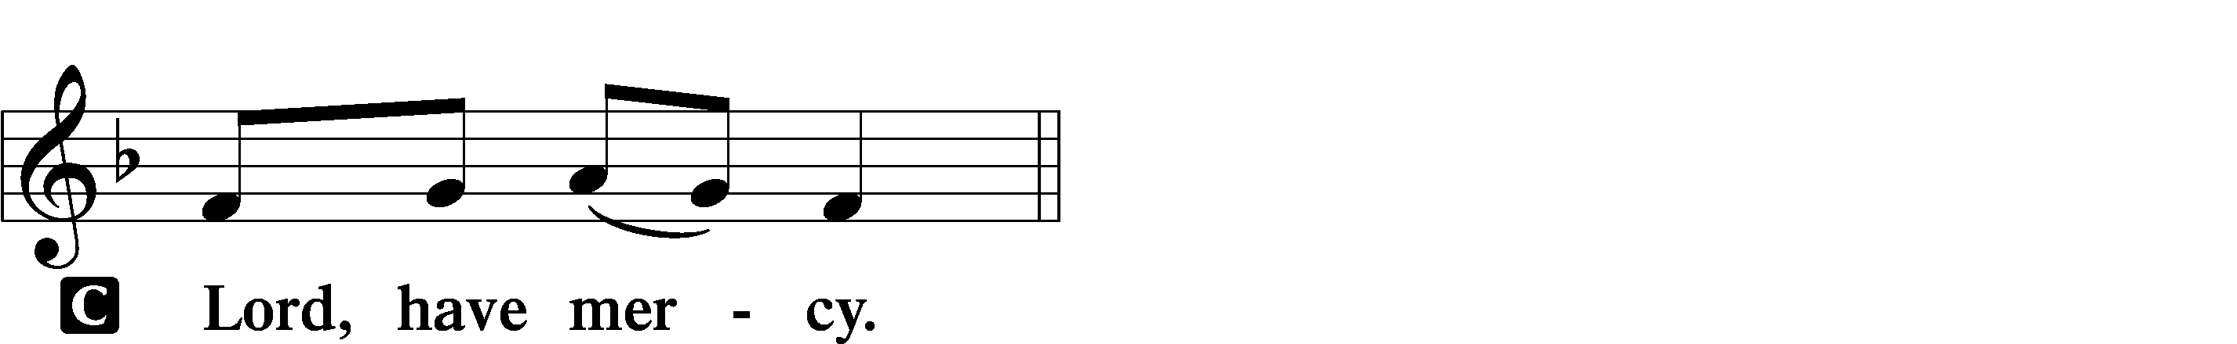

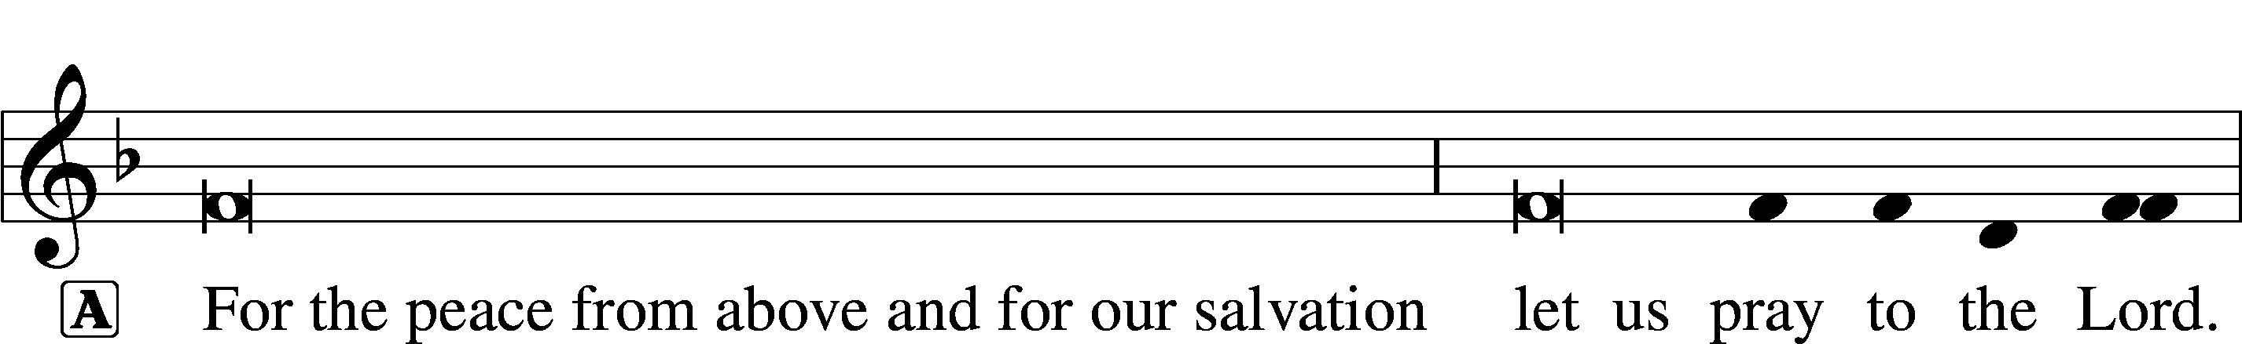

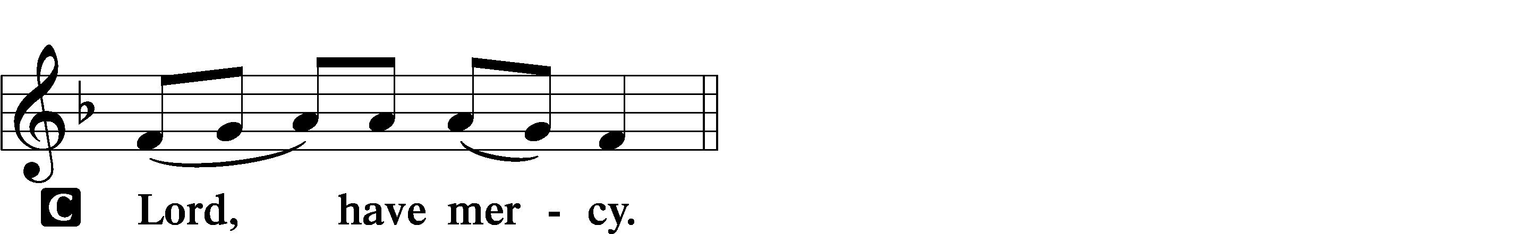

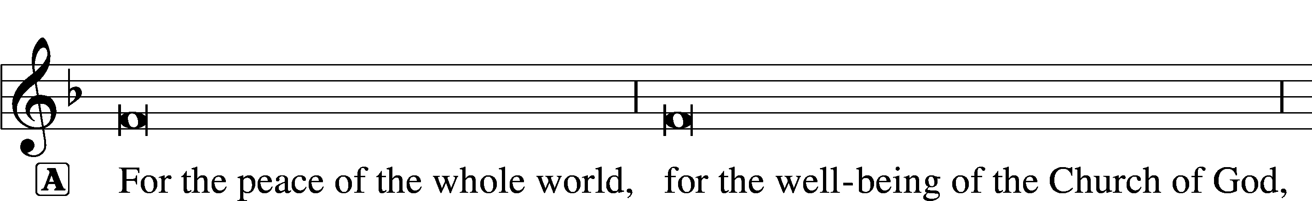

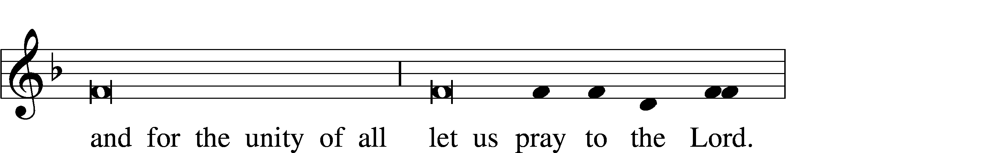

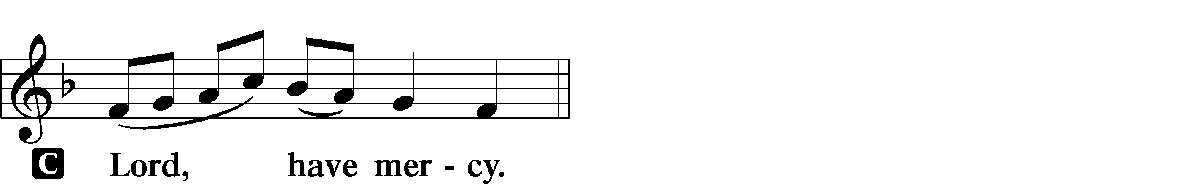

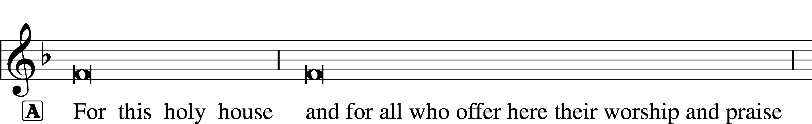

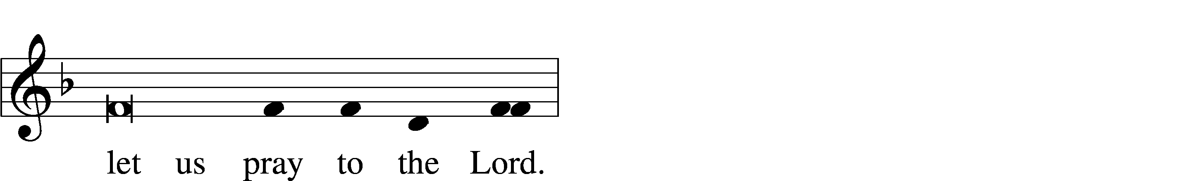

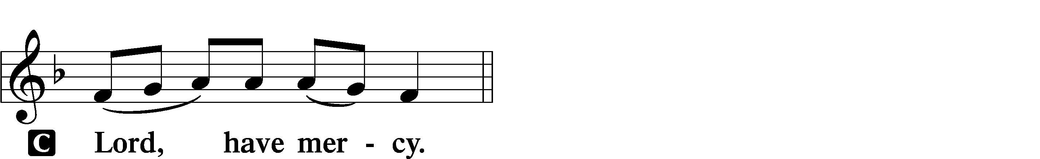

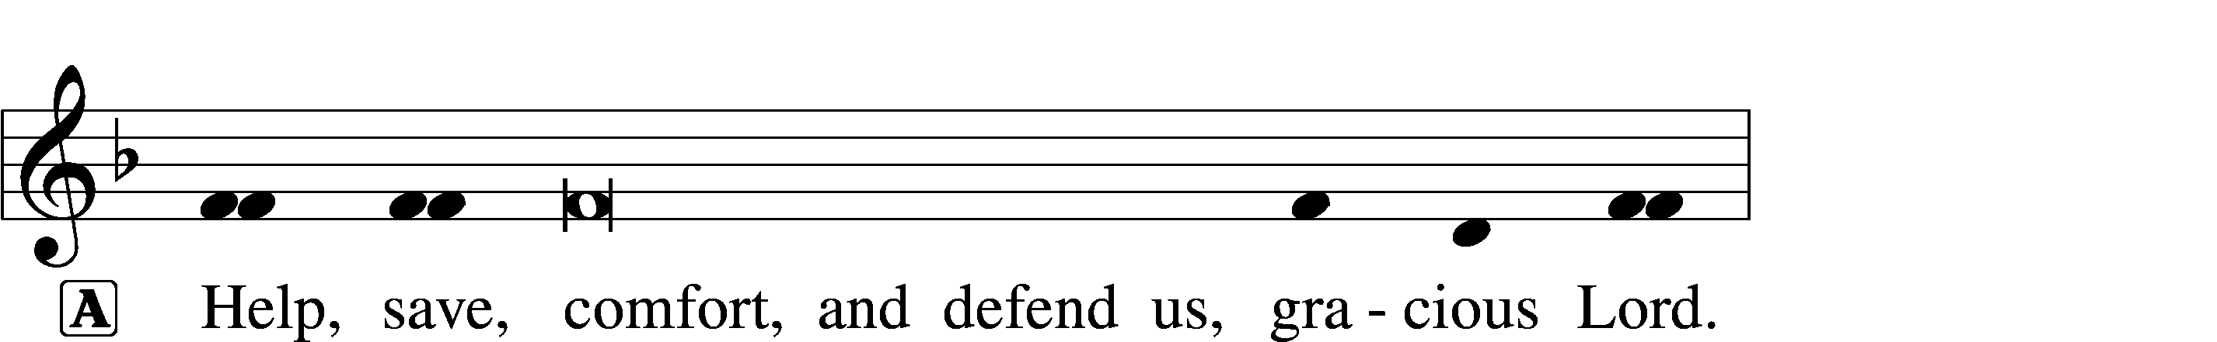



Salutation and Collect of the Day

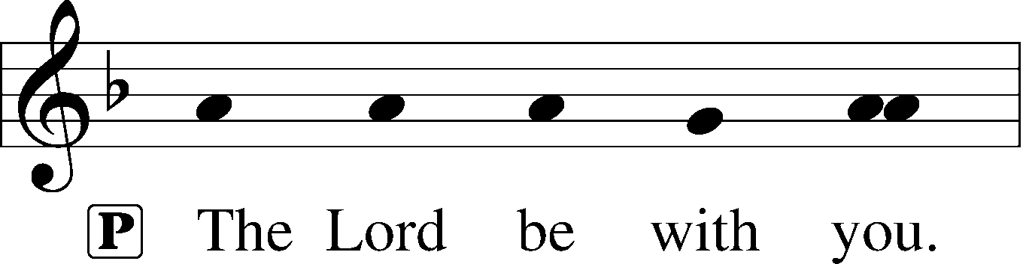

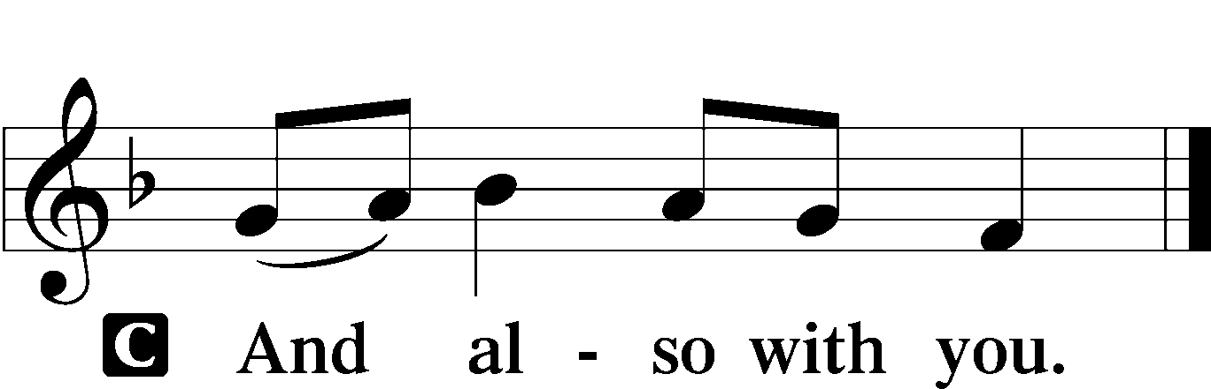

P Let us pray.

Lord Jesus Christ, we implore You to hear our prayers and to lighten the darkness of our hearts by Your gracious visitation; for You live and reign with the Father and the Holy Spirit, one God, now and forever.

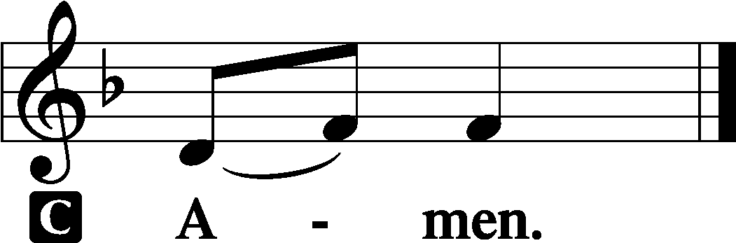

Sit

Old Testament Reading Isaiah 40:1–11

Comfort, comfort my people, says your God.  
Speak tenderly to Jerusalem,  
 and cry to her  
that her warfare is ended,  
 that her iniquity is pardoned,  
that she has received from the Lord’s hand  
 double for all her sins.  
A voice cries:  
“In the wilderness prepare the way of the Lord;  
 make straight in the desert a highway for our God.  
Every valley shall be lifted up,  
 and every mountain and hill be made low;  
the uneven ground shall become level,  
 and the rough places a plain.

And the glory of the Lord shall be revealed,  
 and all flesh shall see it together,  
 for the mouth of the Lord has spoken.”

A voice says, “Cry!”  
 And I said, “What shall I cry?”  
All flesh is grass,  
 and all its beauty is like the flower of the field.  
The grass withers, the flower fades  
 when the breath of the Lord blows on it;  
 surely the people are grass.  
The grass withers, the flower fades,  
 but the word of our God will stand forever.

Get you up to a high mountain,  
 O Zion, herald of good news;  
lift up your voice with strength,  
 O Jerusalem, herald of good news;  
 lift it up, fear not;  
say to the cities of Judah,  
 “Behold your God!”  
Behold, the Lord God comes with might,  
 and his arm rules for him;  
behold, his reward is with him,  
 and his recompense before him.  
He will tend his flock like a shepherd;  
 he will gather the lambs in his arms;  
he will carry them in his bosom,  
 and gently lead those that are with young.

A This is the Word of the Lord.

C **Thanks be to God.**

Gradual Psalm 80:1–2

You who are enthroned upon the cherubim, shine forth.  
 Stir up your might and come to save us!  
**Give ear, O Shepherd of Israel,  
 you who lead Joseph like a flock!**

Epistle 1 Corinthians 4:1–5

This is how one should regard us, as servants of Christ and stewards of the mysteries of God. Moreover, it is required of stewards that they be found trustworthy. But with me it is a very small thing that I should be judged by you or by any human court. In fact, I do not even judge myself. I am not aware of anything against myself, but I am not thereby acquitted. It is the Lord who judges me. Therefore do not pronounce judgment before the time, before the Lord comes, who will bring to light the things now hidden in darkness and will disclose the purposes of the heart. Then each one will receive his commendation from God.

A This is the Word of the Lord.

C **Thanks be to God.**

Stand

Alleluia and Verse LSB 156

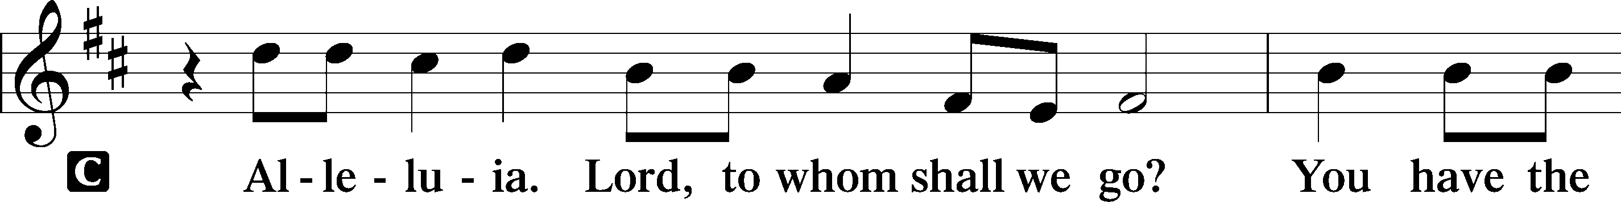

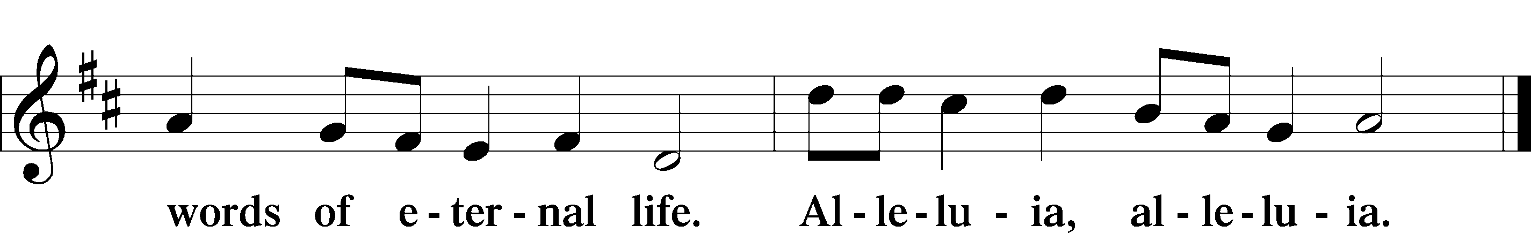

Holy Gospel Matthew 11:2–11

P The Holy Gospel according to St. Matthew, the eleventh chapter.

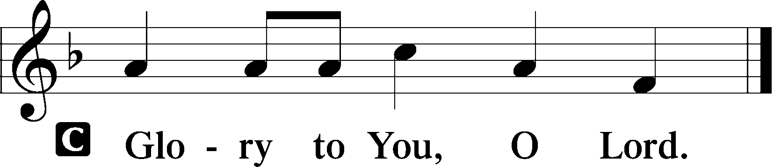

When John heard in prison about the deeds of the Christ, he sent word by his disciples and said to him, “Are you the one who is to come, or shall we look for another?” And Jesus answered them, “Go and tell John what you hear and see: the blind receive their sight and the lame walk, lepers are cleansed and the deaf hear, and the dead are raised up, and the poor have good news preached to them. And blessed is the one who is not offended by me.”

As they went away, Jesus began to speak to the crowds concerning John: “What did you go out into the wilderness to see? A reed shaken by the wind? What then did you go out to see? A man dressed in soft clothing? Behold, those who wear soft clothing are in kings’ houses. What then did you go out to see? A prophet? Yes, I tell you, and more than a prophet. This is he of whom it is written,

“‘Behold, I send my messenger before your face,  
 who will prepare your way before you.’

Truly, I say to you, among those born of women there has arisen no one greater than John the Baptist. Yet the one who is least in the kingdom of heaven is greater than he.”

P This is the Gospel of the Lord.

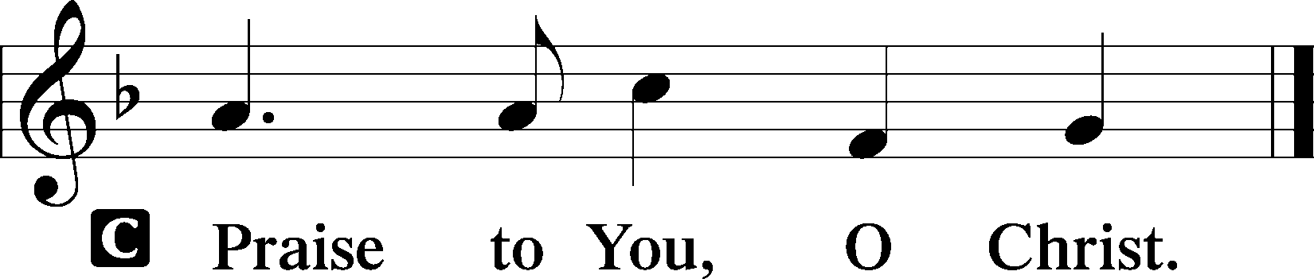

Sit

**Children's Message**

Hark! A Thrilling Voice Is Sounding LSB 345

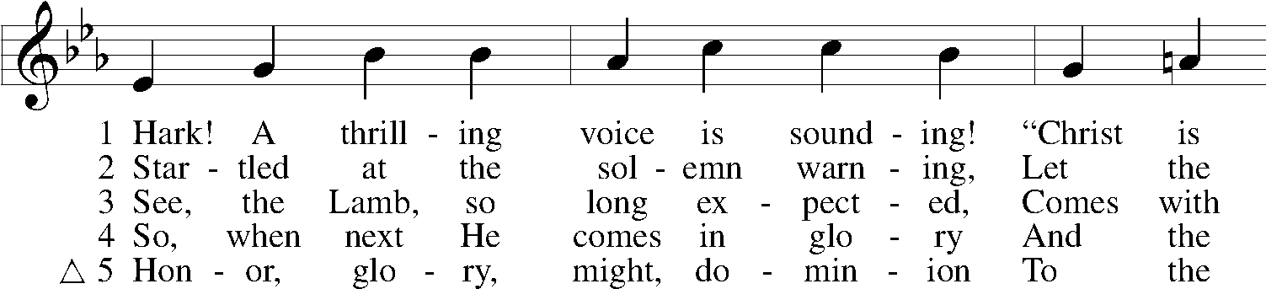

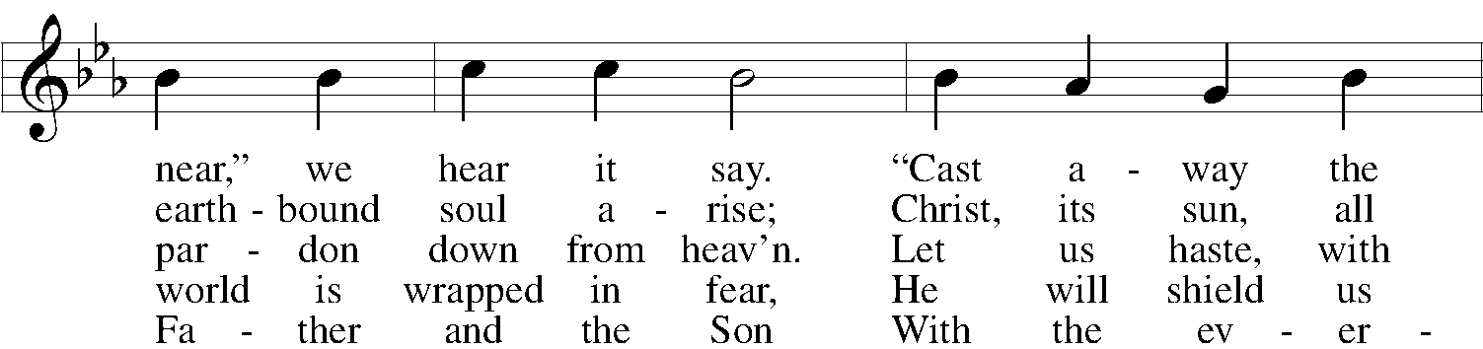

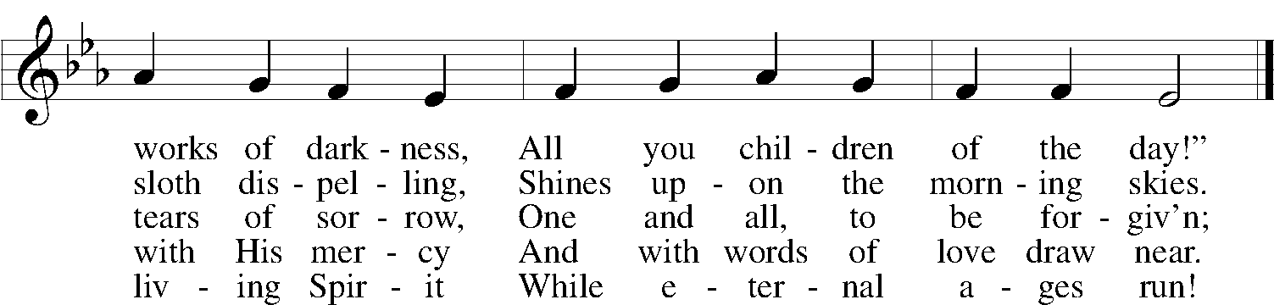

Text: Latin, c. 5th–10th cent.; tr. Edward Caswall, 1814–78, alt.  
Tune: William H. Monk, 1823–89  
Text and tune: Public domain

Sermon

Stand

Nicene Creed

C **I believe in one God,**

**the Father Almighty,**

**maker of heaven and earth**

**and of all things visible and invisible.**

**And in one Lord Jesus Christ,**

**the only-begotten Son of God,**

**begotten of His Father before all worlds,**

**God of God, Light of Light,**

**very God of very God,**

**begotten, not made,**

**being of one substance with the Father,**

**by whom all things were made;**

**who for us men and for our salvation came down from heaven**

**and was incarnate by the Holy Spirit of the virgin Mary**

**and was made man;**

**and was crucified also for us under Pontius Pilate.**

**He suffered and was buried.**

**And the third day He rose again according to the Scriptures**

**and ascended into heaven**

**and sits at the right hand of the Father.**

**And He will come again with glory to judge both the living and the dead,**

**whose kingdom will have no end.**

**And I believe in the Holy Spirit,**

**the Lord and giver of life,**

**who proceeds from the Father and the Son,**

**who with the Father and the Son together is worshiped and glorified,**

**who spoke by the prophets.**

**And I believe in one holy Christian and apostolic Church,**

**I acknowledge one Baptism for the remission of sins,**

**and I look for the resurrection of the dead**

**and the life** T **of the world to come. Amen.**

Prayer of the Church

Sit

Offering

*“Rejoice Greatly” Zechariah 9:9 arr. By George Friderich Handel*

Stand

Offertory LSB 159

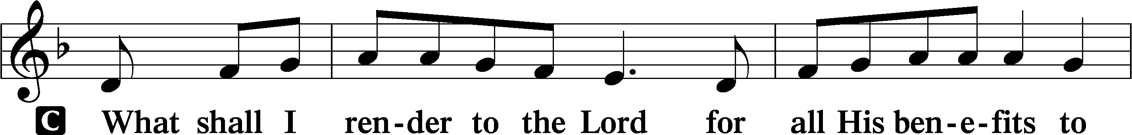

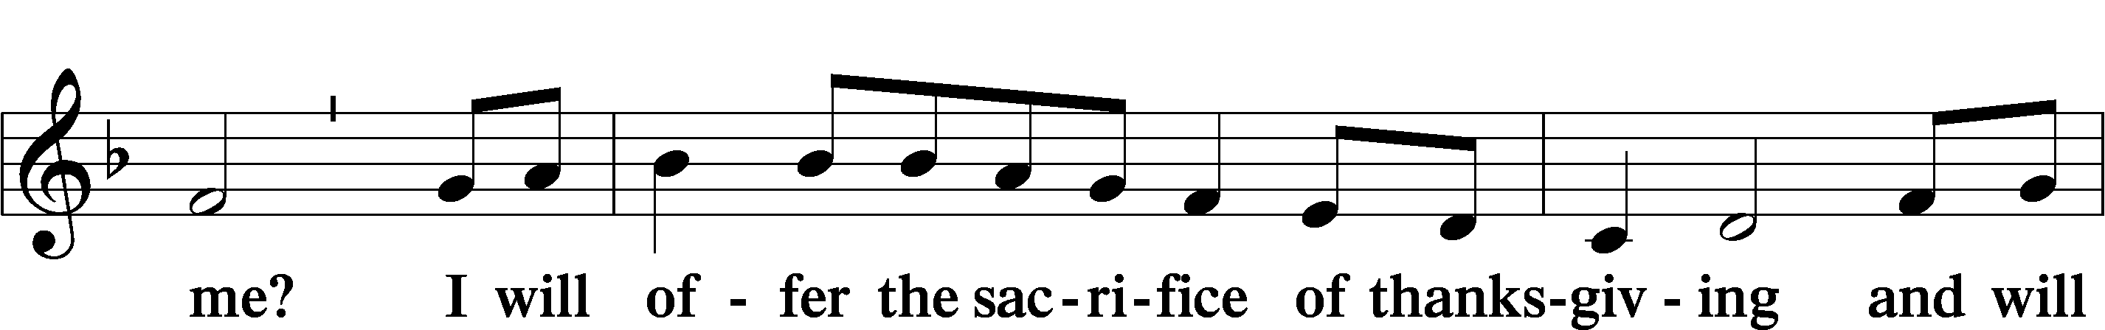

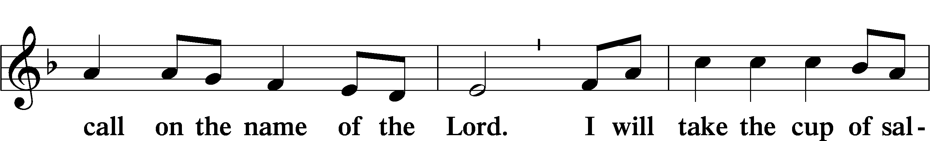

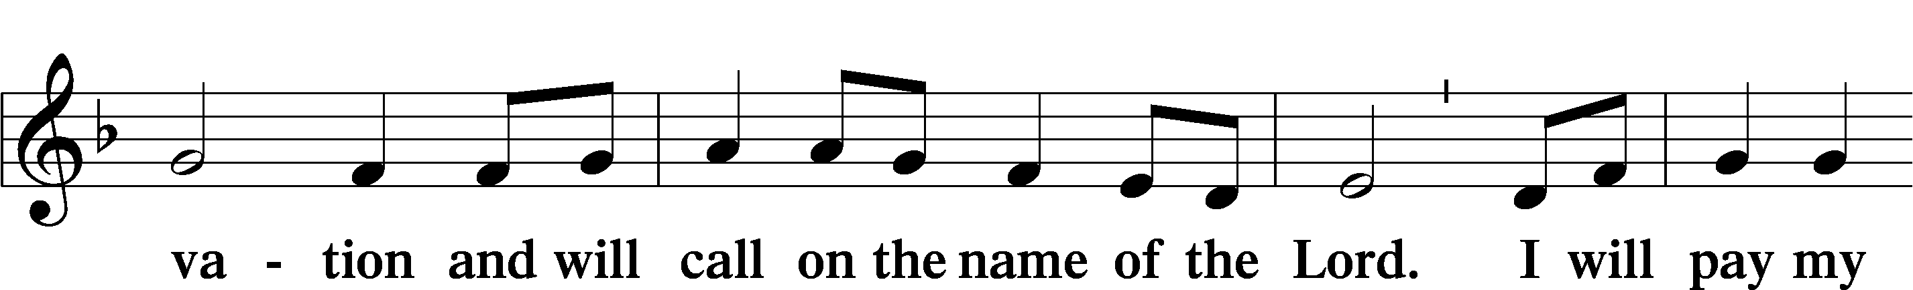

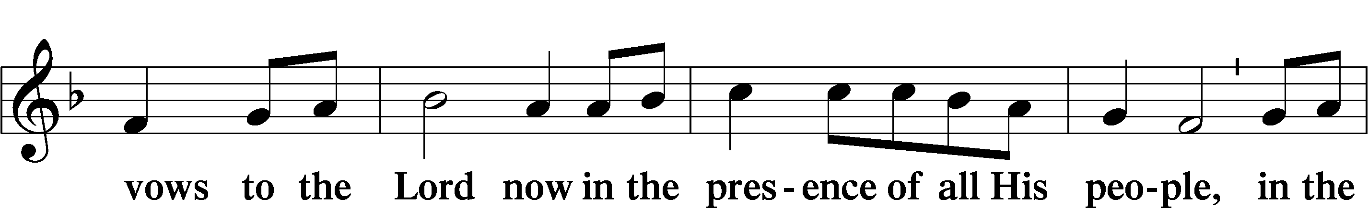

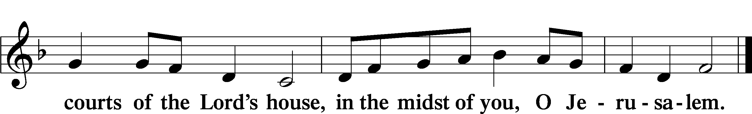

# Service of the Sacrament

Preface LSB 160

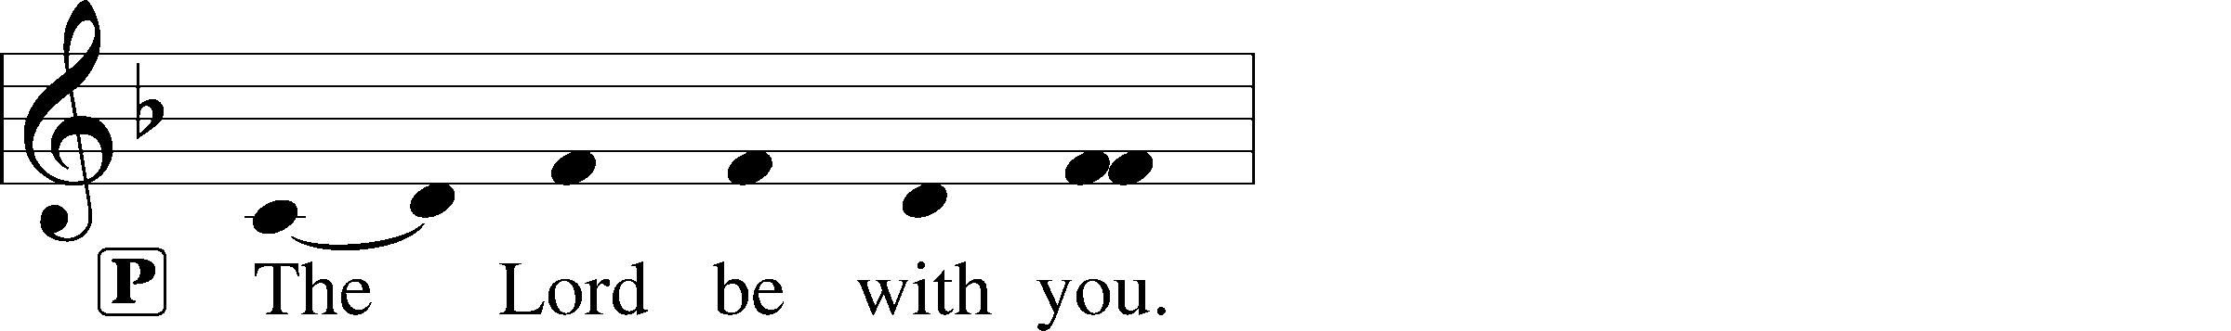

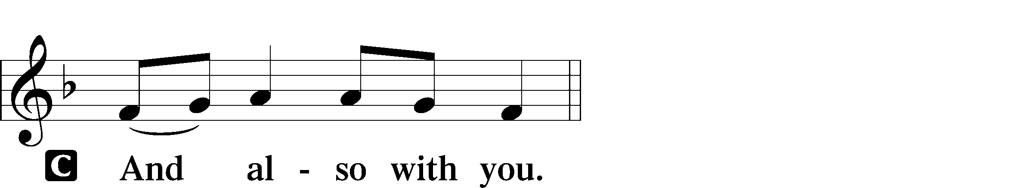

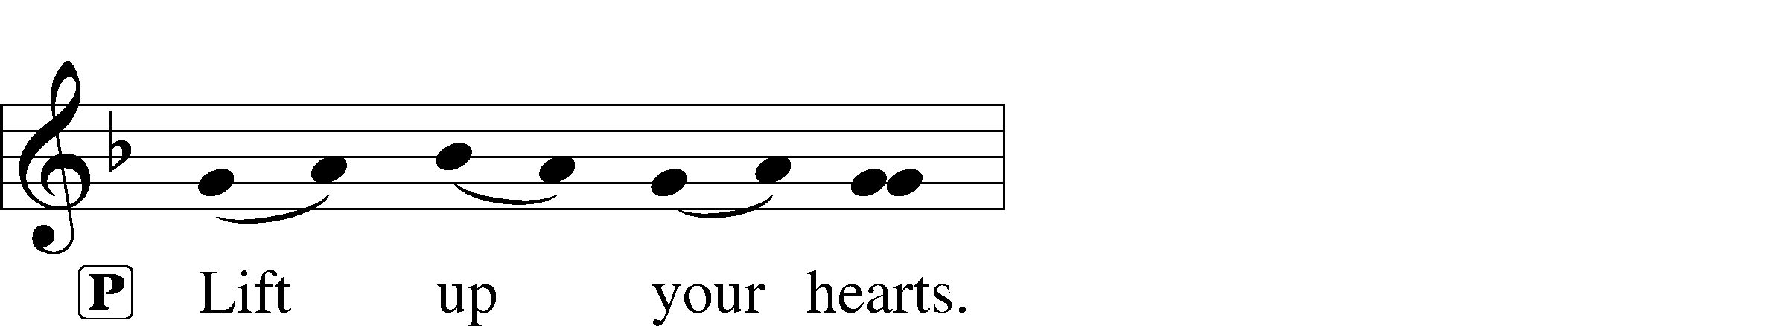



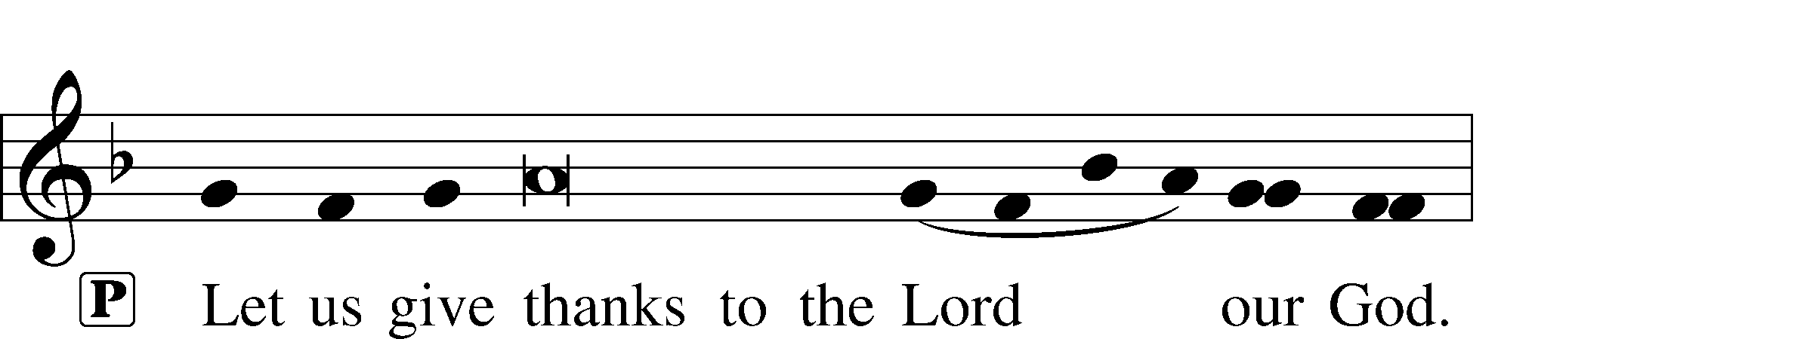

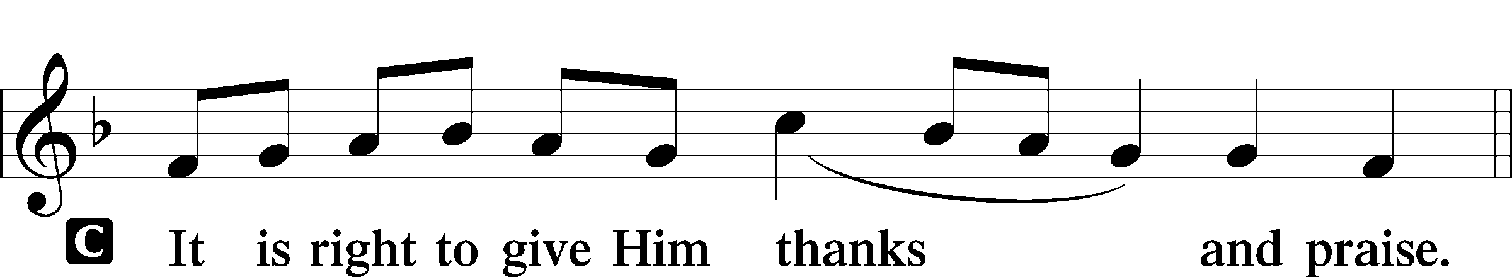

Proper Preface

Sanctus LSB 161

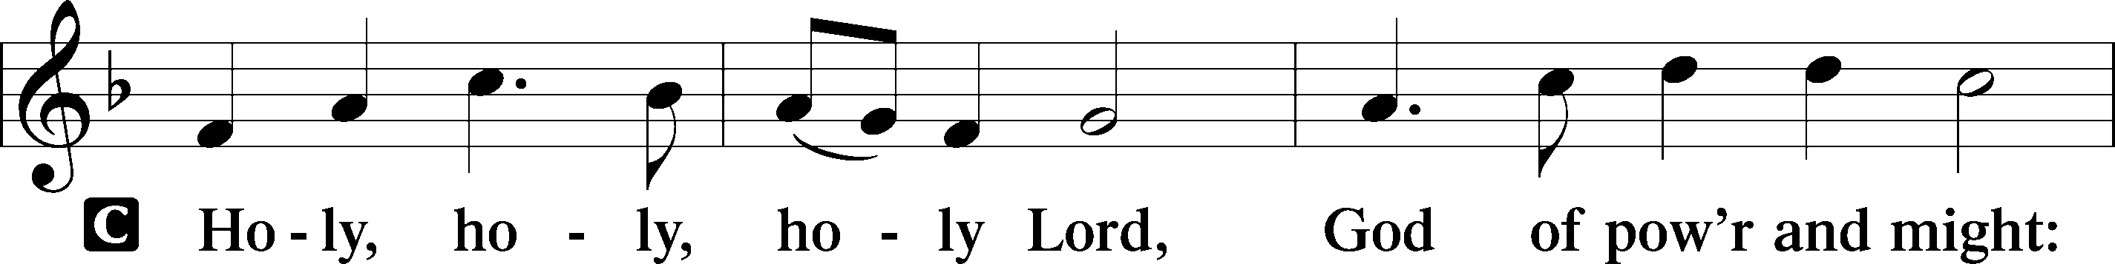

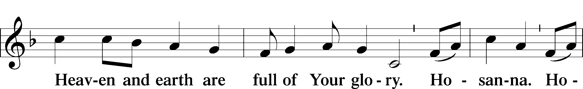

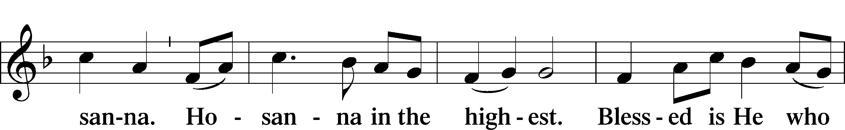

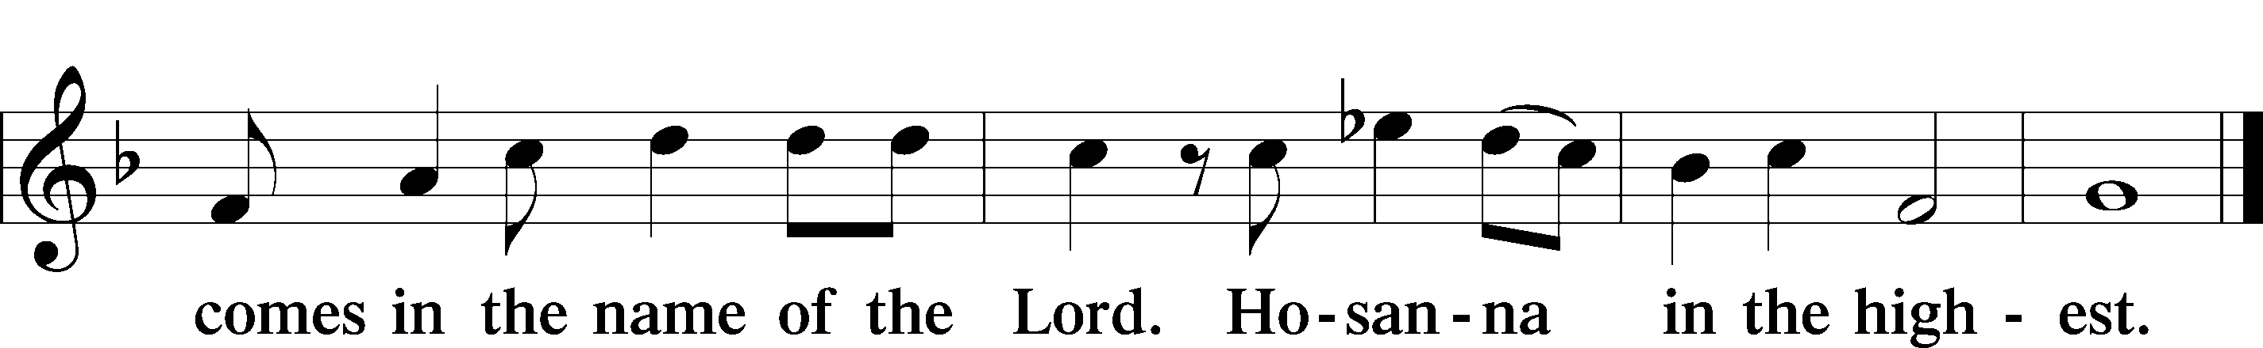

Prayer of Thanksgiving LSB 161

P Blessed are You, Lord of heaven and earth, for You have had mercy on those whom You created and sent Your only-begotten Son into our flesh to bear our sin and be our Savior. With repentant joy we receive the salvation accomplished for us by the all-availing sacrifice of His body and His blood on the cross.

Gathered in the name and the remembrance of Jesus, we beg You, O Lord, to forgive, renew, and strengthen us with Your Word and Spirit. Grant us faithfully to eat His body and drink His blood as He bids us do in His own testament. Gather us together, we pray, from the ends of the earth to celebrate with all the faithful the marriage feast of the Lamb in His kingdom, which has no end. Graciously receive our prayers; deliver and preserve us. To You alone, O Father, be all glory, honor, and worship, with the Son and the Holy Spirit, one God, now and forever.

C **Amen.**

The Words of Our Lord

P Our Lord Jesus Christ, on the night when He was betrayed, took bread, and when He had given thanks, He broke it and gave it to the disciples and said: “Take, eat; this is My T body, which is given for you. This do in remembrance of Me.”

In the same way also He took the cup after supper, and when He had given thanks, He gave it to them, saying: “Drink of it, all of you; this cup is the new testament in My T blood, which is shed for you for the forgiveness of sins. This do, as often as you drink it, in remembrance of Me.”

Proclamation of Christ

P As often as we eat this bread and drink this cup, we proclaim the Lord’s death until He comes.

C **Amen. Come, Lord Jesus.**

P O Lord Jesus Christ, only Son of the Father, in giving us Your body and blood to eat and to drink, You lead us to remember and confess Your holy cross and passion, Your blessed death, Your rest in the tomb, Your resurrection from the dead, Your ascension into heaven, and Your coming for the final judgment. So remember us in Your kingdom and teach us to pray:

Lord’s Prayer

C **Our Father who art in heaven,**

**hallowed be Thy name,**

**Thy kingdom come,**

**Thy will be done on earth**

**as it is in heaven;**

**give us this day our daily bread;**

**and forgive us our trespasses**

**as we forgive those**

**who trespass against us;**

**and lead us not into temptation,**

**but deliver us from evil.**

**For Thine is the kingdom**

**and the power and the glory**

**forever and ever. Amen.**

Pax Domini LSB 163

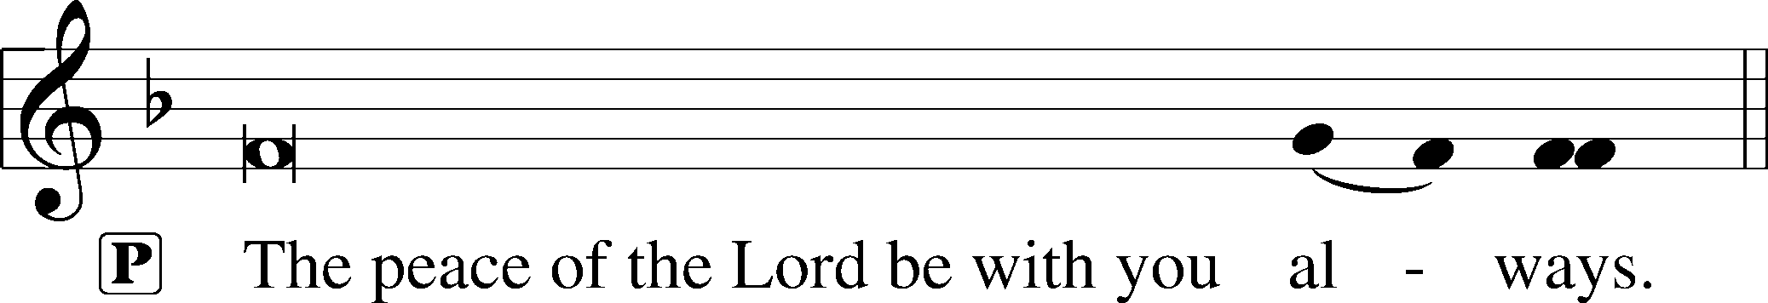



Agnus Dei LSB 163

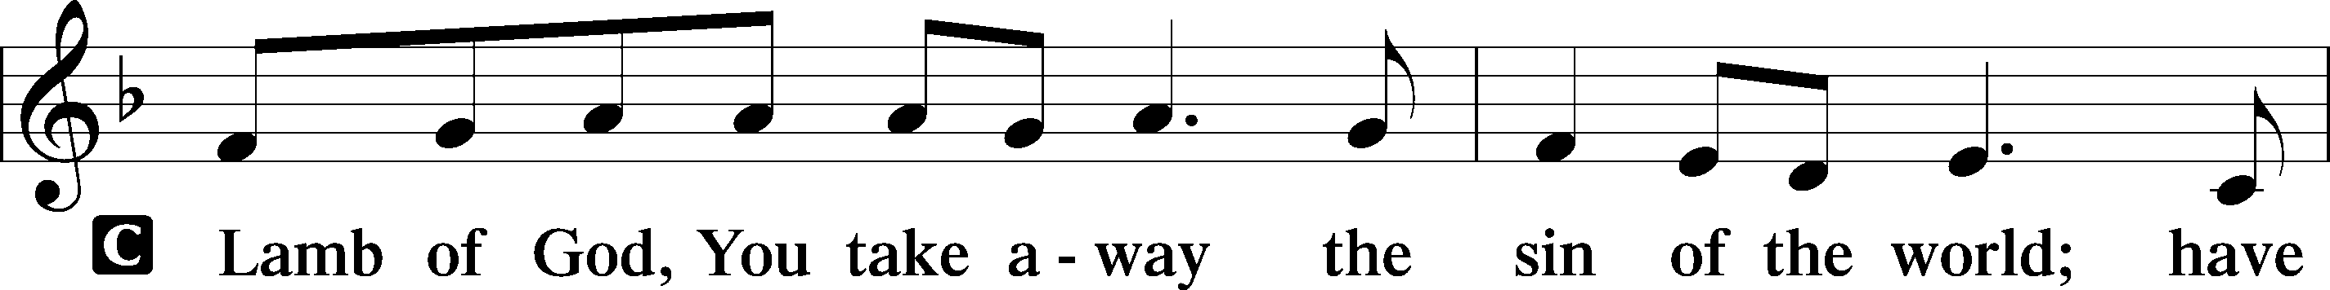

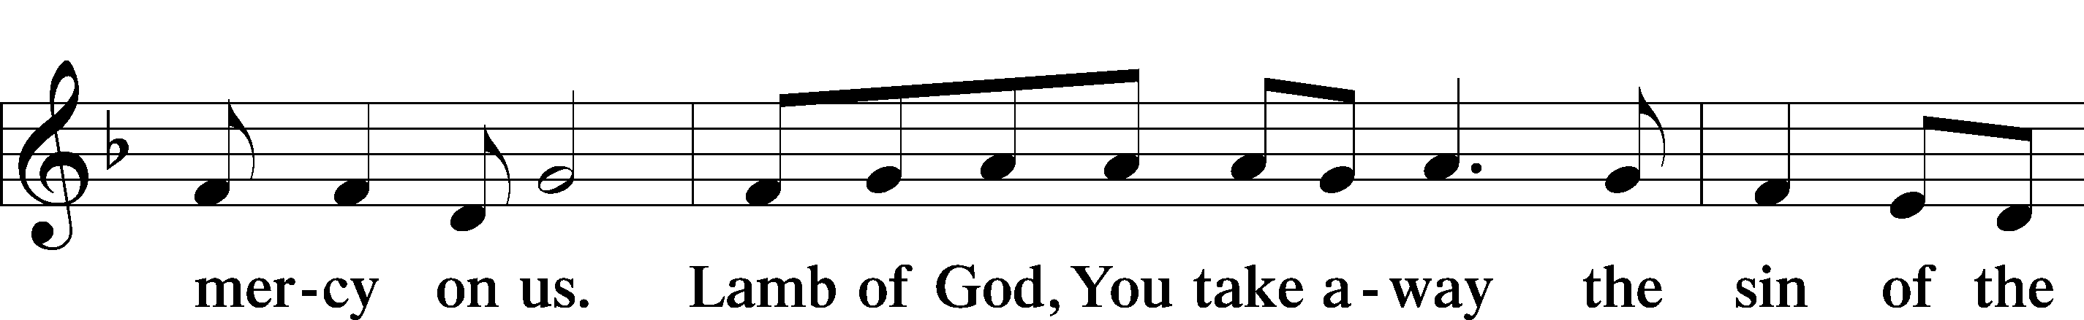

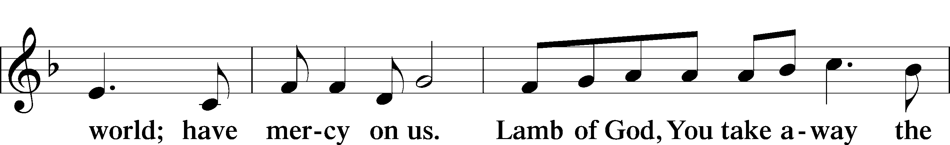

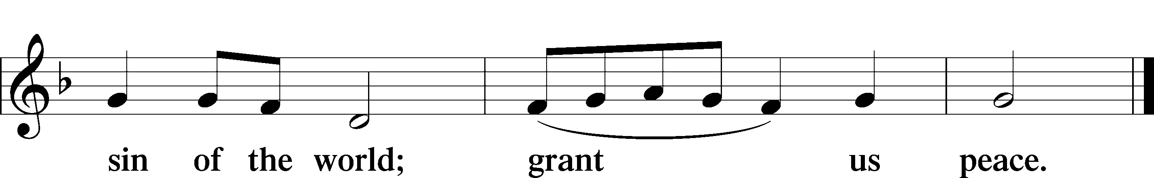

Sit

**Distribution**

“The Angel Gabriel from Heaven Came”

Hark the Glad Sound LSB 349

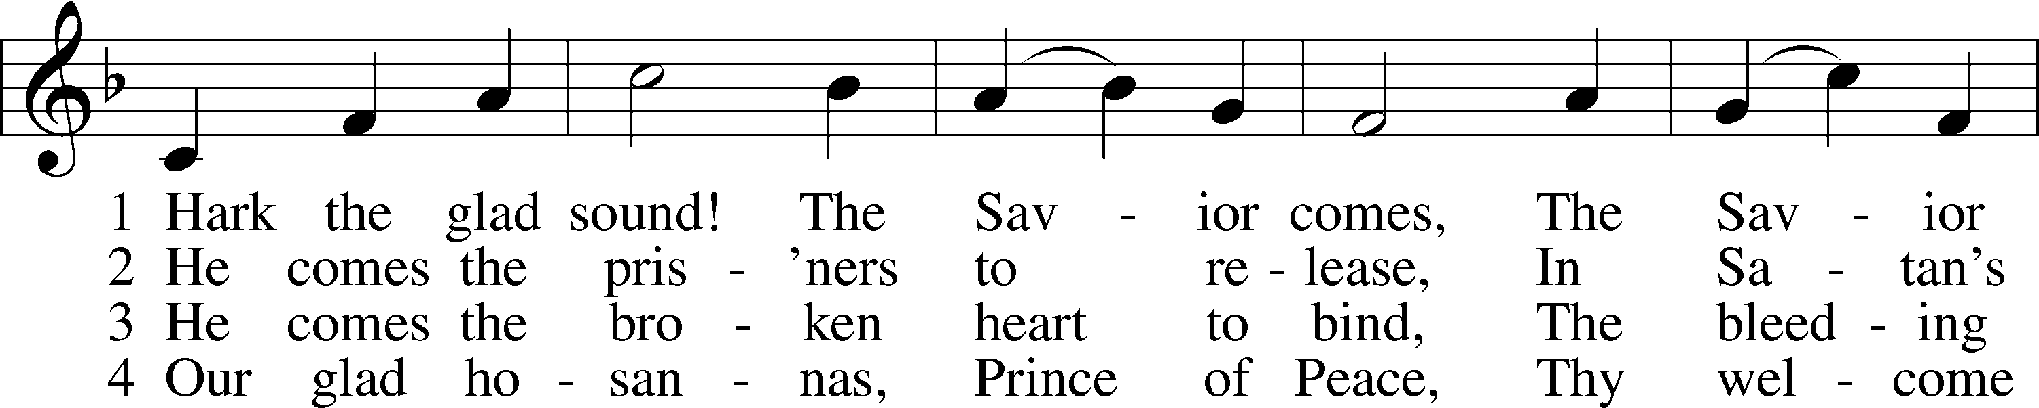

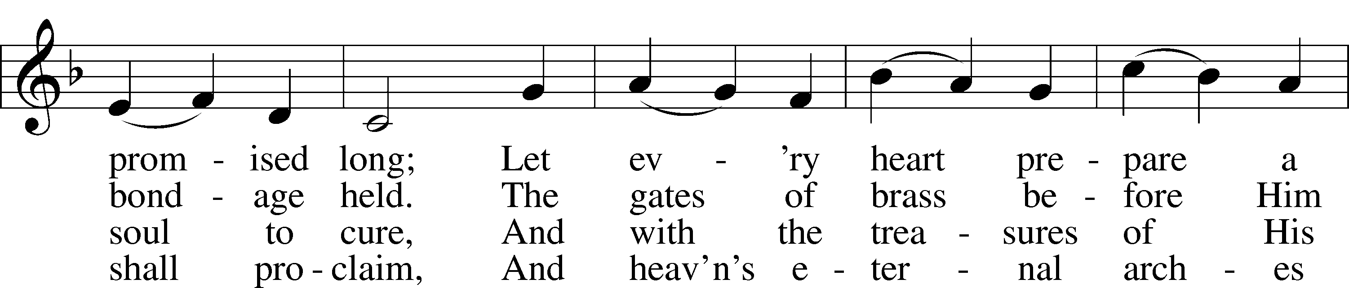

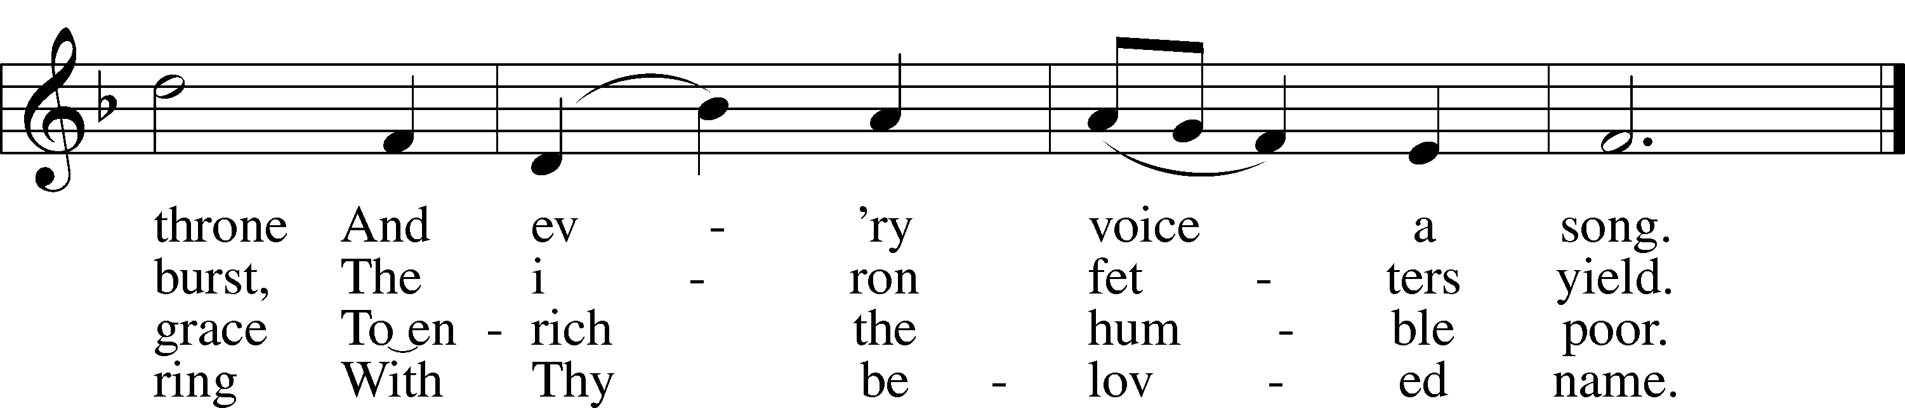

Text: Philip Doddridge, 1702–51  
Tune: Thomas Haweis, 1734–1820  
Text and tune: Public domain

Come, Thou Long-Expected Jesus LSB 338

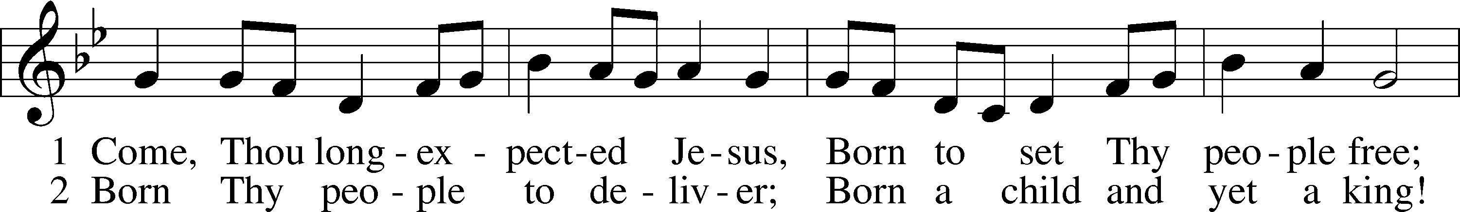

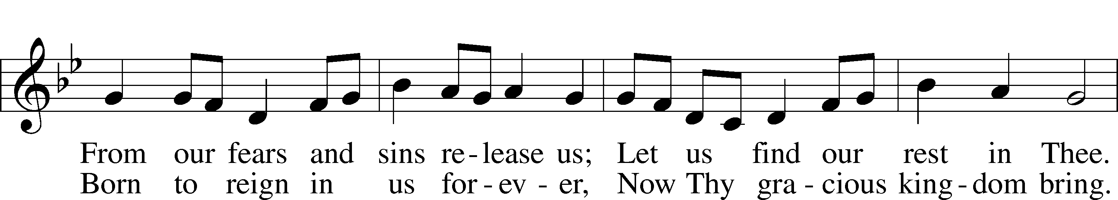

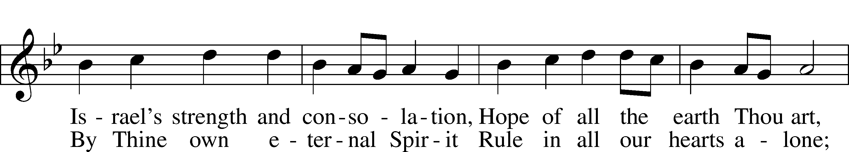

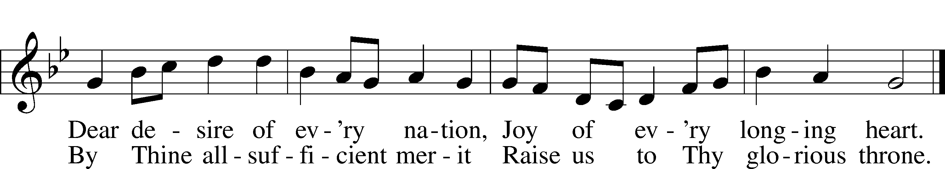

Text: Charles Wesley, 1707–88, alt.  
Tune: Southern Harmony, 1835, New Haven  
Text and tune: Public domain

Stand

Nunc Dimittis LSB 165

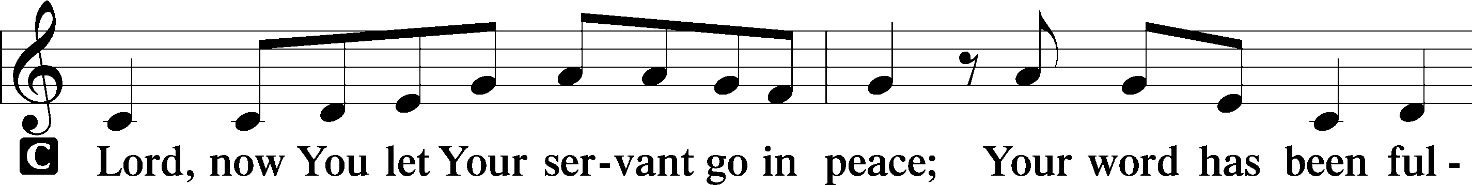

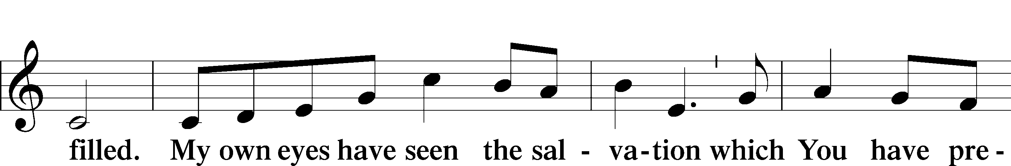

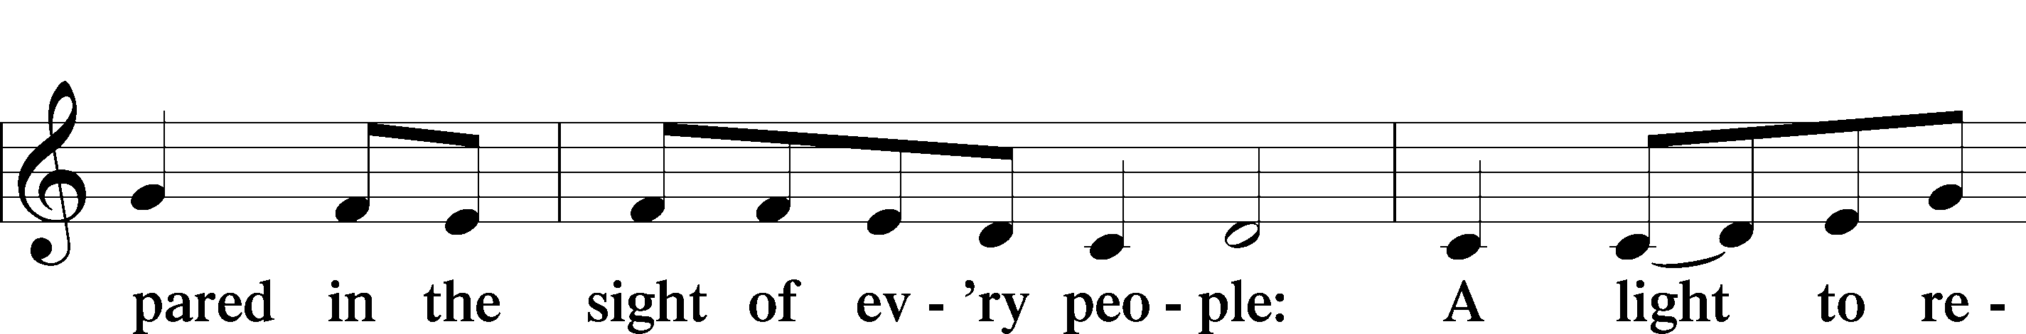

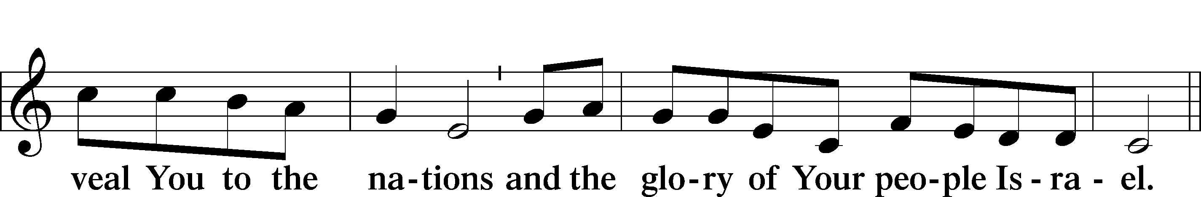

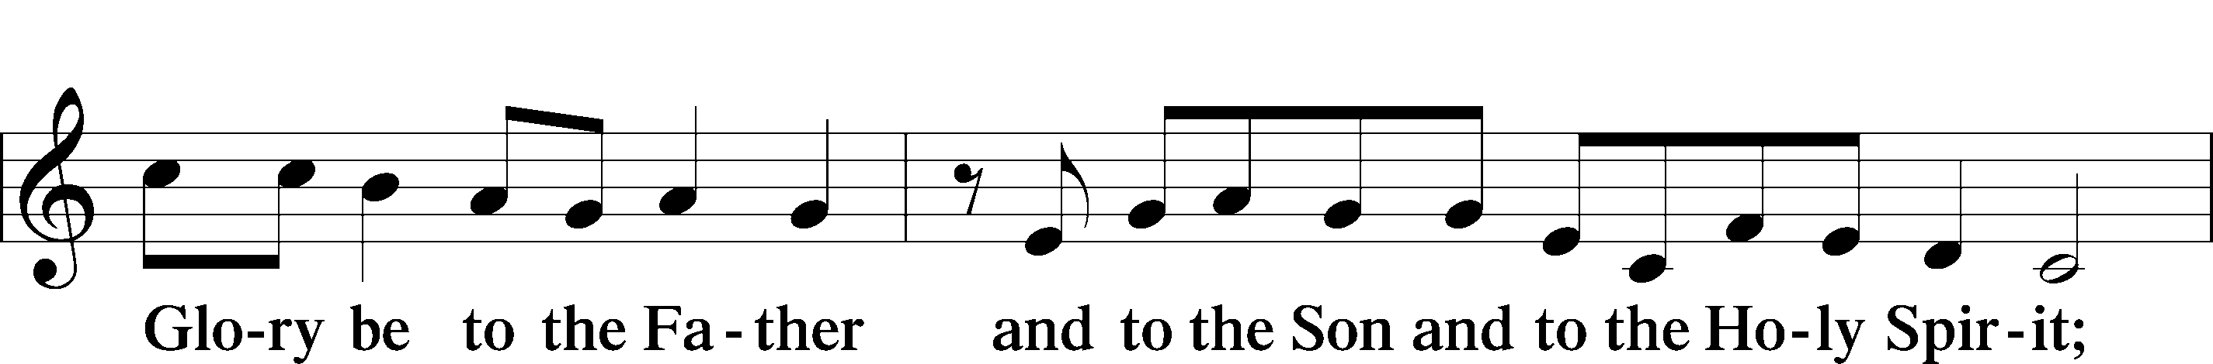

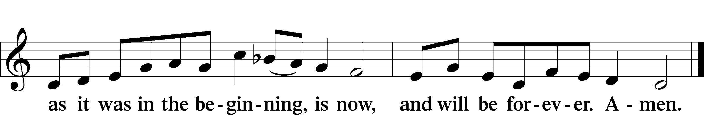

Post-Communion Collect

Benediction LSB 166

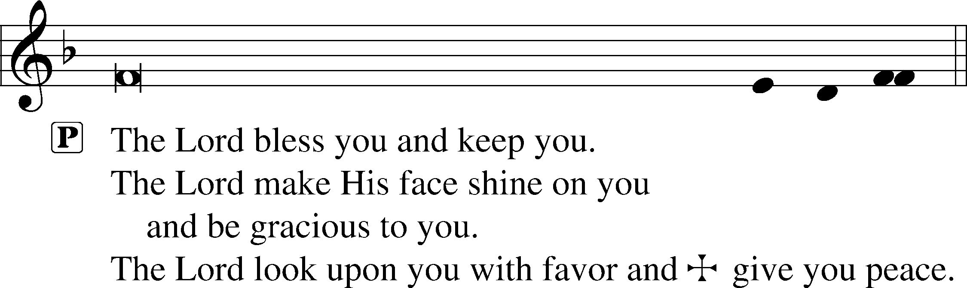

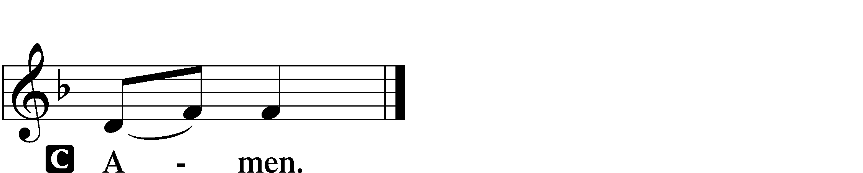

On Jordan’s Bank the Baptist’s Cry LSB 344

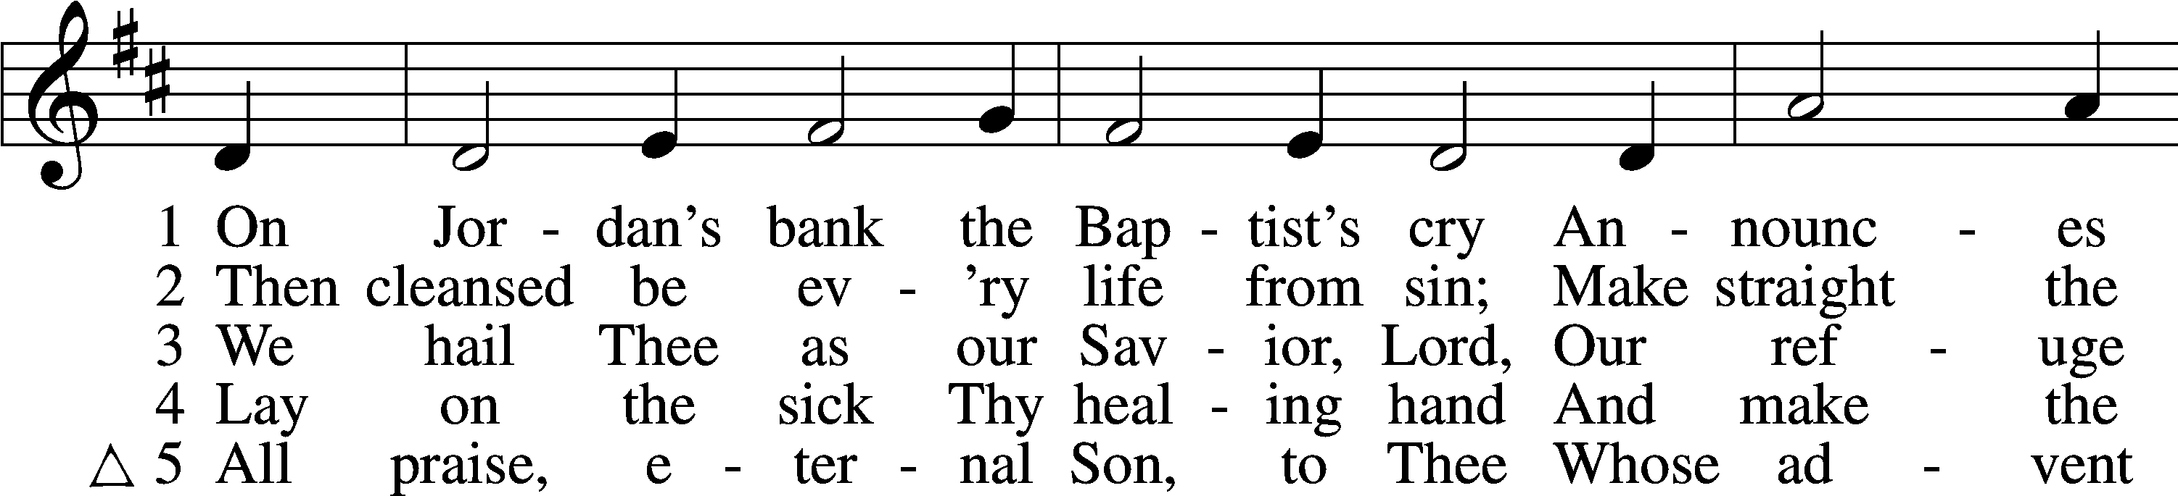

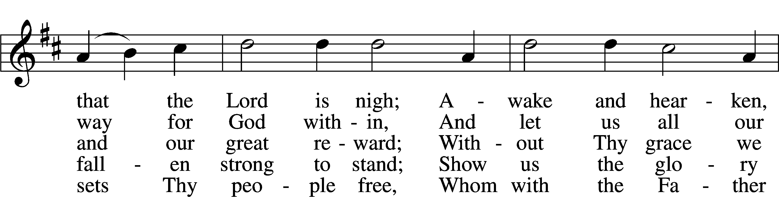

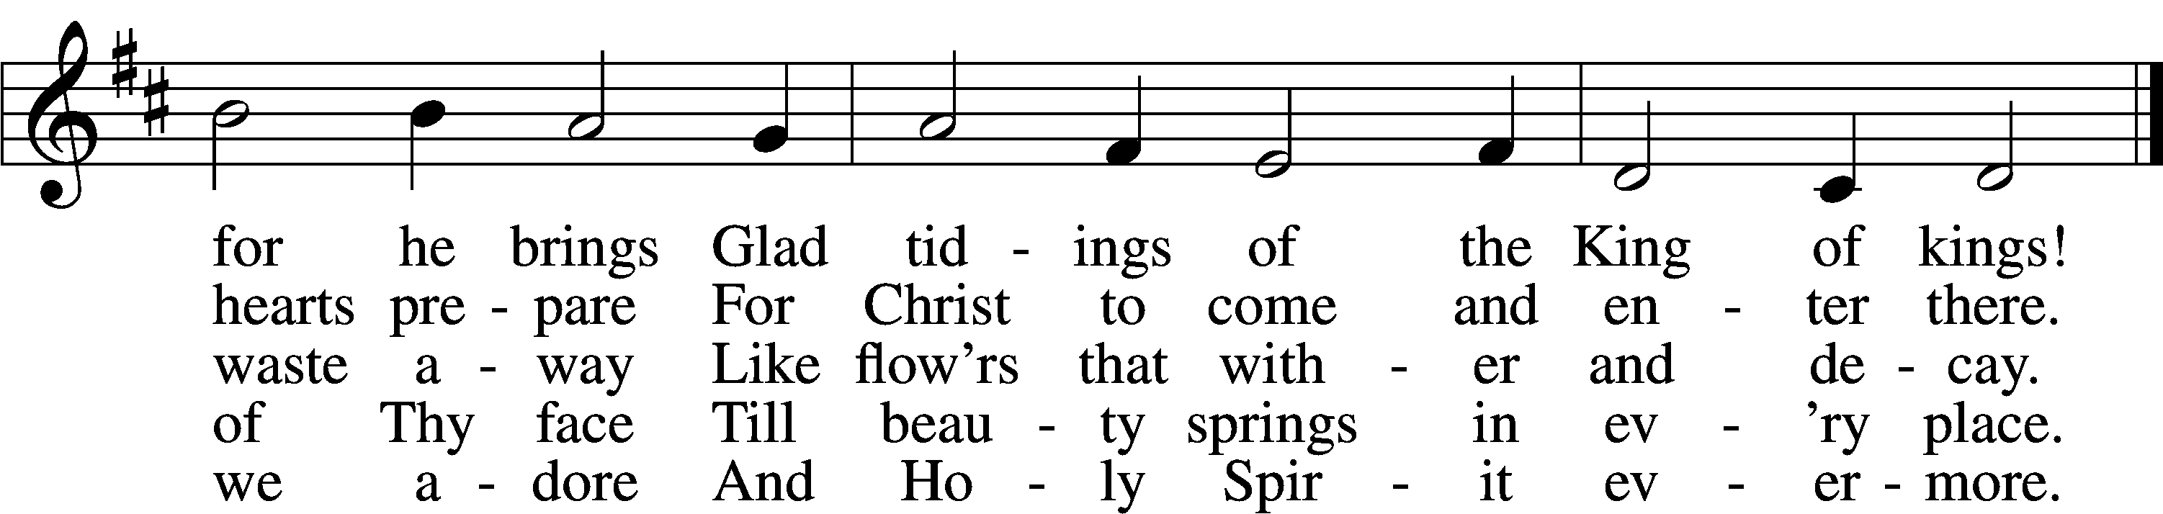

Text: Charles Coffin, 1676–1749; tr. composite  
Tune: adapt. Michael Praetorius, 1571–1621  
Text and tune: Public domain

Acknowledgments

Unless otherwise indicated, Scripture quotations are from the ESV® Bible (The Holy Bible, English Standard Version®), copyright © 2001 by Crossway, a publishing ministry of Good News Publishers. Used by permission. All rights reserved.

Created by Lutheran Service Builder © 2023 Concordia Publishing House.

**Serving Our Lord in His House Today:**

Pastor: Rev. Noah J. Rogness

Organist: Rebecca Moseley

Pianist: David Moseley & Lydia Rogness

Soloist: Meredith Moseley

Elders: Dillin Lafferty & Josh Church

TAnnouncementsT

**Altar Flowers:** Altar flowers are placed today by Mike & Brenda Preuss.

**Midweek Advent:**The final soup dinner will take place this Wednesday, December 20, 2023. We will also have an Advent Hymn Sing.  Join your brothers and sisters at Good Shepherd Wednesday prior to the Advent service for a hymn sing. The congregation will sing a combination of Advent and Christmas hymns, beginning at 6:45 PM!

**Secret Sister 2024:** Good Shepherd Secret Sister was a success in 2023 and will continue in 2024. Applications to join the fun will be on the Ushers table to be completed and turned in to Shawn Zabinski or Kathy Berg by the date on the form. Questions feel free to ask Shawn or Kathy.

**Bible Class Update:** Today the Adult Bible Class will begin examining the church year and liturgy of the Divine Service. This is an excellent opportunity to learn why Christmas falls on December 25 or Easter moves from one date to another.

We'll also consider parts of the liturgy, like what it means when the pastor says before the Lord’s Supper, “With angels, archangels, and the whole company of heaven, we laud and magnify your glorious name evermore praising you and saying…” This will be your chance over the coming weeks and months to ask the pastor, “Why do we do what we do?"

**Donations for Ft. Wayne seminary Co-op:** The Good Shepherd Women’s LWML are spearheading a collection of items to be taken to the Ft. Wayne seminary

Co-op to assist seminarians and their families with the cost of living during their time at the seminary. The Co-op consists of clothing, blankets, sheets, and pillowcases, nonperishable food items, and cleaning products of all kinds. There is a Thrivent card available for our use to purchase some of these items, but we are also asking for help from the congregation to provide help with this project also. Donations can be dropped off through January 14th and any help is greatly appreciated. Questions, contact Kathy Berg or Pastor Rogness.

**Our Worship attendance last week:** Sunday: 86

Wednesday: 59

Total: 145

**Scripture Lessons for next week:** Deuteronomy 18:15-19

Philippians 4:4-7

John 1:19-28

***Our Week With Our Lord:***

**Today**  **9:00am** **Divine Service w/Holy Communion** 10:30am Adult Bible Study & Sunday School

**Wednesday** 5:30pm Advent Soup Supper

5:45pm Confirmation Class

6:45pm Advent Hymn Sing

**7:00pm** **Advent Evening Prayer**

**Thursday** 10:30am YAH/Bday Group, meet at church to assemble

baskets, lunch to follow at P’Zone

**Friday** 12:00pm Newsletter Article Submission Deadline

**Sunday** **9:00am** **Divine Service w/Holy Communion**

**7:00pm Lessons & Carols Candlelight Service**

