The Eve of the Circumcision and Name of Jesus
December 31, 2023

Good Shepherd Lutheran Church
1221 LaGrange Ave, Tomah, WI 54660 Phone (608)374-2444
Pastor: Noah J. Rogness T pastor.rogness@goodsheptomah.com
Visit our web site @ www.goodsheptomah.weebly.com
Lutheran Church-Missouri Synod

Visitor Information: Welcome to Good Shepherd, we are glad you are joining us for worship!
If you need help following along with the hymnal and the order of worship, please sit close to a member and ask questions. The ushers in the back of the sanctuary are also here to assist you in any way they can. The Nursery located at the left of the sanctuary entrance is reserved for nursing mothers. Please join us for refreshments, Sunday School, and Bible Study in the Fellowship Hall at 10:15 a.m.

Holy Communion: According to God’s Word and in unity with Christ’s Church, Good Shepherd Lutheran Church practices closed communion. We do this not to offend, but because Scripture teaches that those communing together should be completely unified in their confession of the Faith. In this Sacrament we are not only joined to Christ our Head who is present in His body and blood, but are also knit together with one another as His Body, in which there should be no division of belief. We would love to see you join our congregation and communion.
If you are interested in becoming a member or have questions or concerns about this Biblical doctrine, please speak with the Pastor.

Theme for the Eve of the Circumcision and Name of Jesus: Our newborn God keeps the Law for us and brings Abraham’s promises to their fulfillment when He is circumcised. It is there that the name above all names is “bestowed on him” (Phil. 2:9), “the name given by the angel before he was conceived in the womb”: Jesus, which means “the Lord saves” (Luke 2:21).
He sheds the first drops of His precious blood in accordance with this name and in anticipation of His cross, “for he will save his people from their sins” (Matt. 1:21). The law’s captivity gives way to the freedom of faith in Christ Jesus, who cuts a new covenant in His blood to be received by faith, whether male or female, Jew or Greek (Gal. 3:23–28). His name is given to us in Holy Baptism, and we are made sons of God and “heirs according to promise,” true offspring of Abraham by faith (Gal. 3:29). Eight days after the celebration of our Lord’s birth, a new “Year of our Lord” is begun in Jesus’ holy name and with His benediction. Jesus is the Lord,
and by this name we are blessed (Num. 6:22–27).
____________________________________________________________________________

Pre-Service Music & Welcome

Divine Service Setting Three – (LSB) 184

Infant Holy, Infant Lowly LSB 393
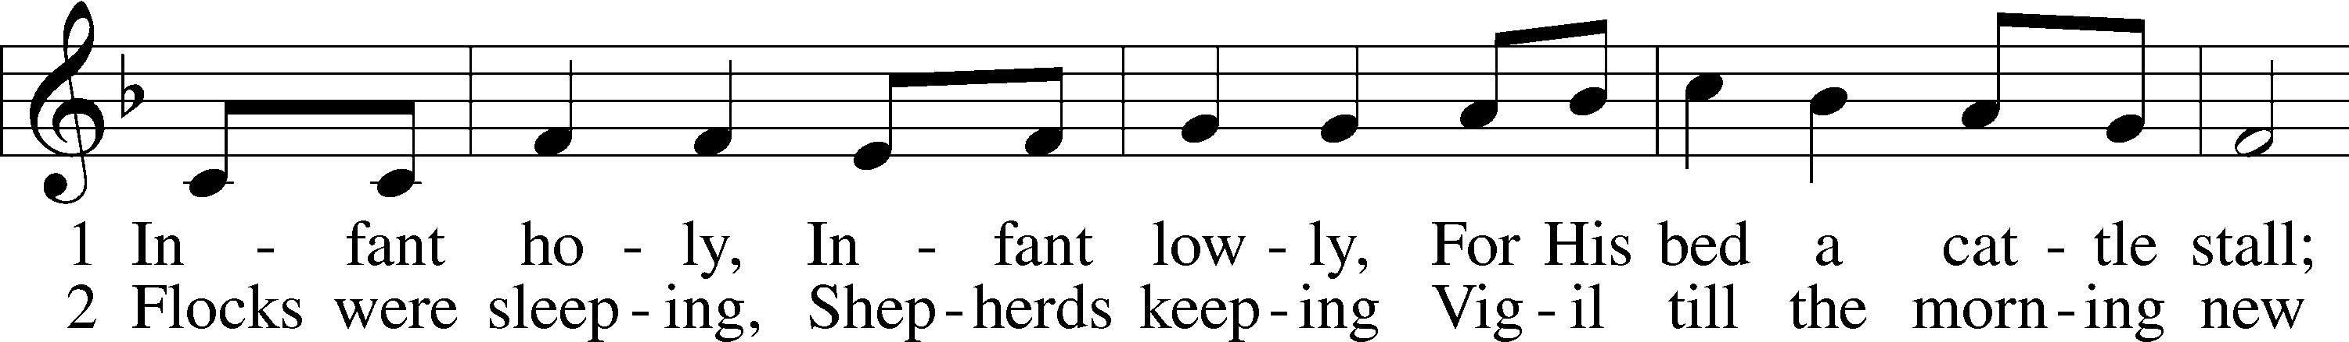
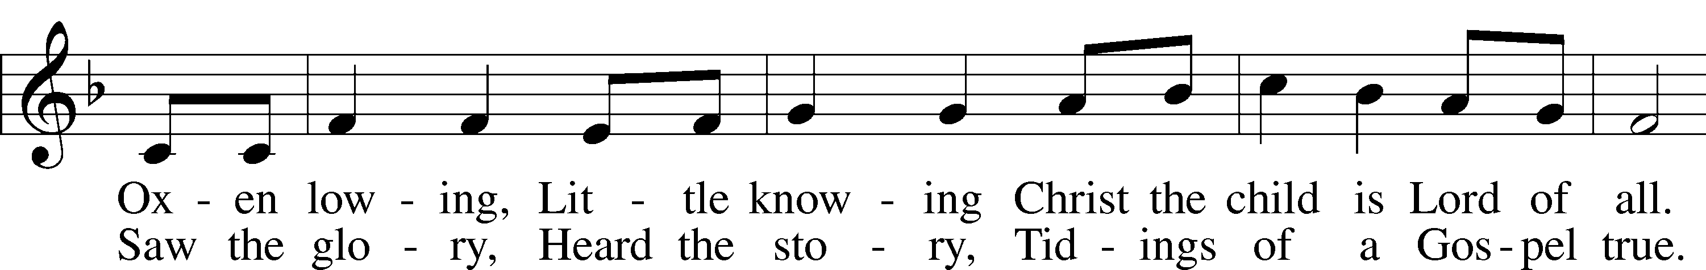
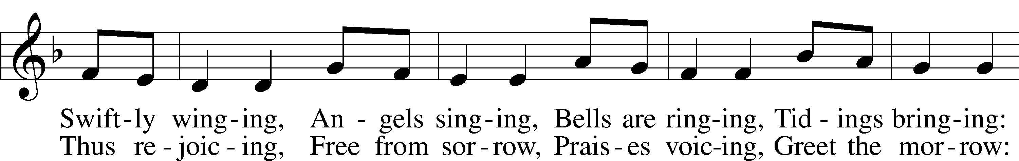
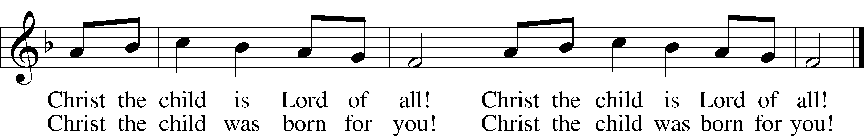
Text: tr. Edith M. G. Reed, 1885–1933, alt.
Text and tune: Polish
Text and tune: Public domain

Confession and Absolution

Stand

The sign of the cross may be made by all in remembrance of their Baptism.

Invocation
P In the name of the Father and of the T Son and of the Holy Spirit.
C Amen.

Exhortation LSB 184
P Beloved in the Lord! Let us draw near with a true heart and confess our sins unto God our Father, beseeching Him in the name of our Lord Jesus Christ to grant us forgiveness.

P Our help is in the name of the Lord,
C who made heaven and earth.
P I said, I will confess my transgressions unto the Lord,
C and You forgave the iniquity of my sin.

Silence for reflection on God’s Word and for self-examination.

Confession of Sins LSB 184
P O almighty God, merciful Father,
C I, a poor, miserable sinner, confess unto You all my sins and iniquities with which I have ever offended You and justly deserved Your temporal and eternal punishment. But I am heartily sorry for them and sincerely repent of them, and I pray You of Your boundless mercy and for the sake of the holy, innocent, bitter sufferings and death of Your beloved Son, Jesus Christ, to be gracious and merciful to me, a poor, sinful being.

Absolution LSB 185
P Upon this your confession, I, by virtue of my office, as a called and ordained servant of the Word, announce the grace of God unto all of you, and in the stead and by the command of my Lord Jesus Christ I forgive you all your sins in the name of the Father and of the T Son and of the Holy Spirit.
C Amen.

Service of the Word

Introit Psalm 40:6–8; antiphon: 40:16
Antiphon
May all who seek you rejoice and be glad in you;
may those who love your salvation say continually, “Great is the Lord!”
Sacrifice and offering you have not desired, but you have given me an open ear.
Burnt offering and sin offering you have not required.
Then I said, “Behold, I have come;
in the scroll of the book it is written of me:
I desire to do your will, O my God;
your law is within my heart.”
Glory be to the Father and to the Son
and to the Holy Spirit;
as it was in the beginning,
is now, and will be forever. Amen.
May all who seek you rejoice and be glad in you;
may those who love your salvation say continually, “Great is the Lord!”

Kyrie LSB 186
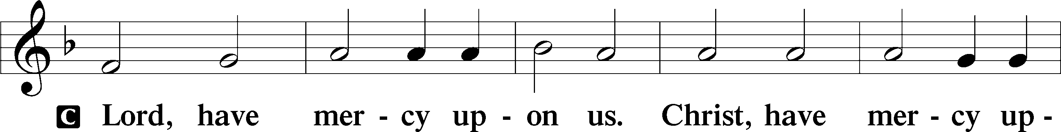
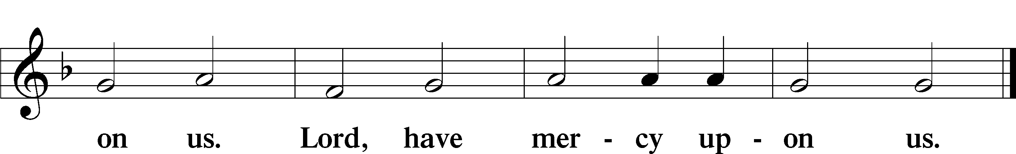

Gloria in Excelsis LSB 187
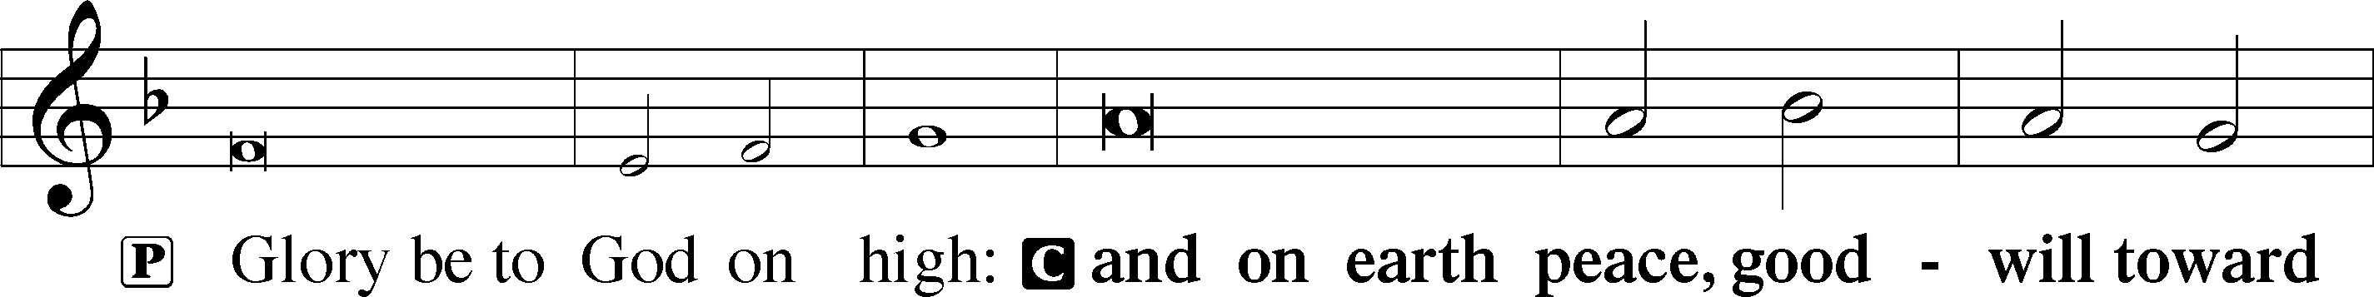
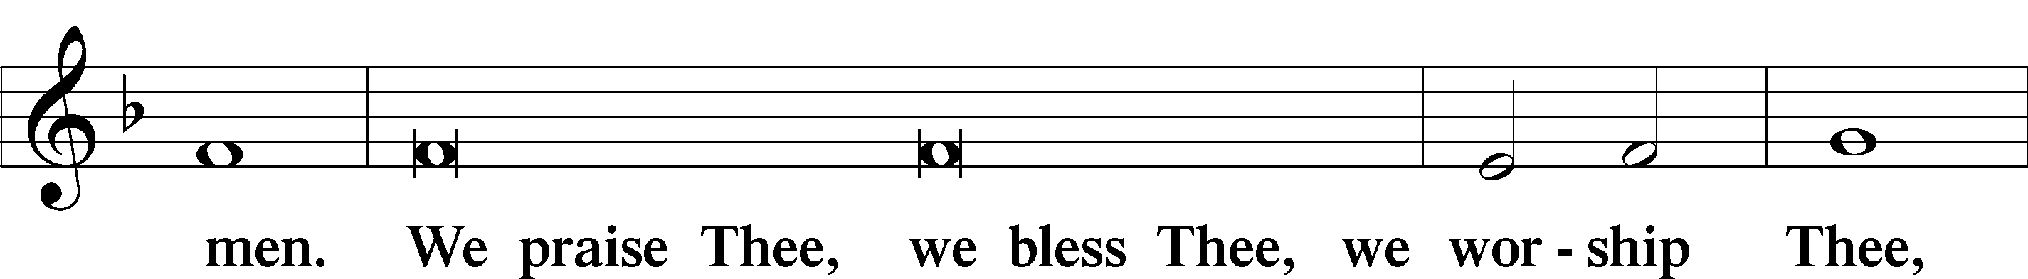
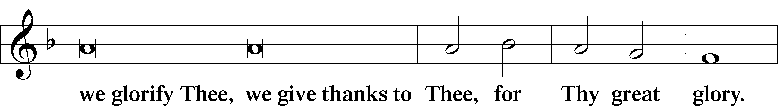
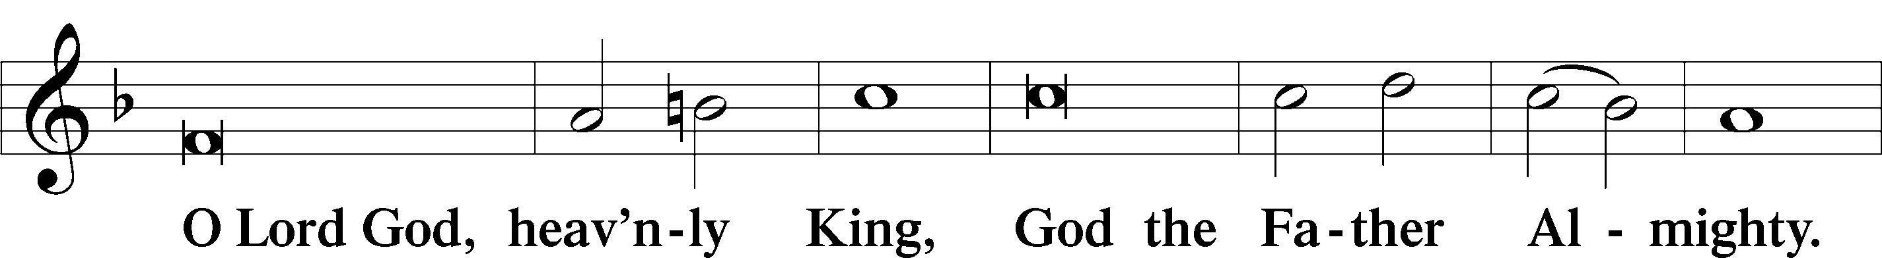
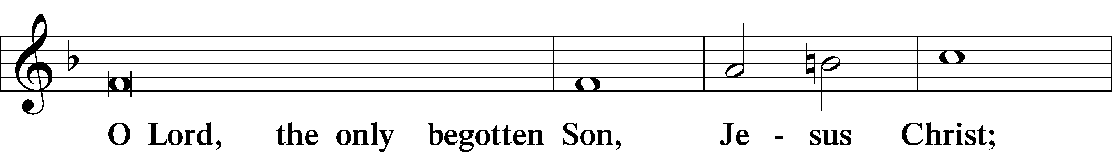
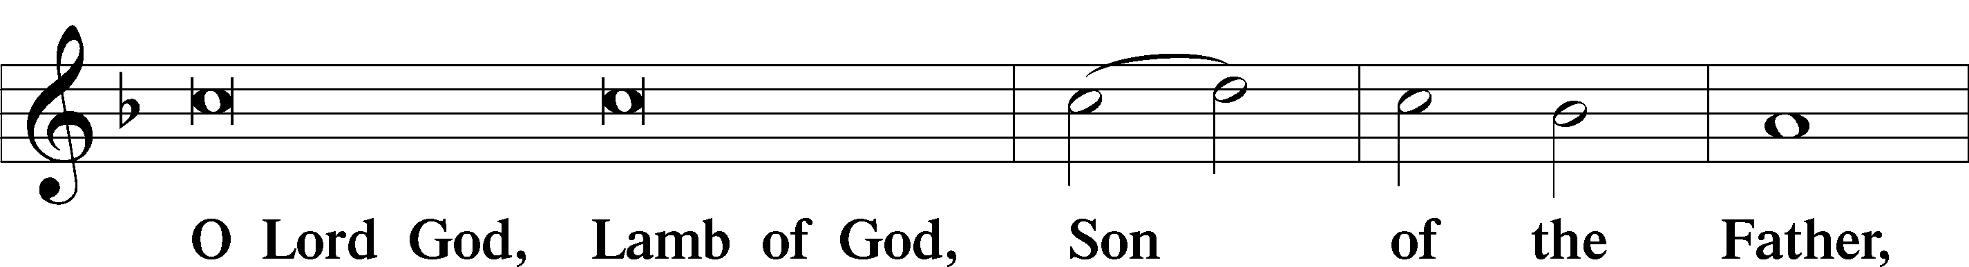
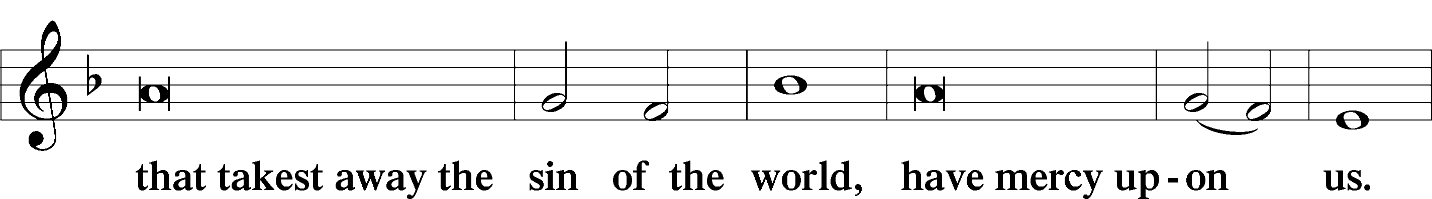
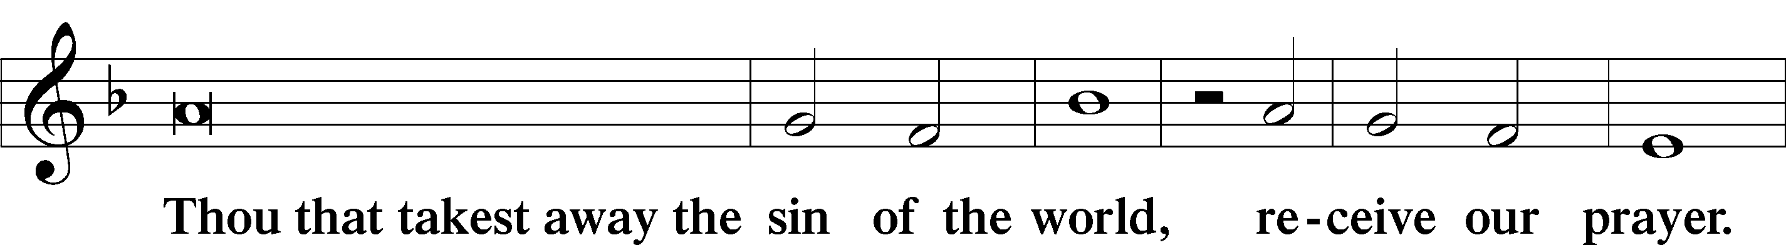
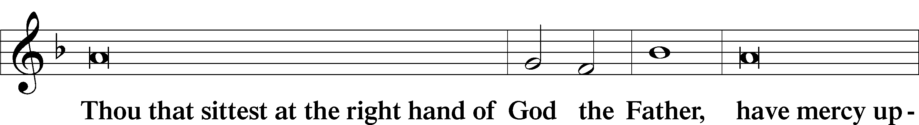
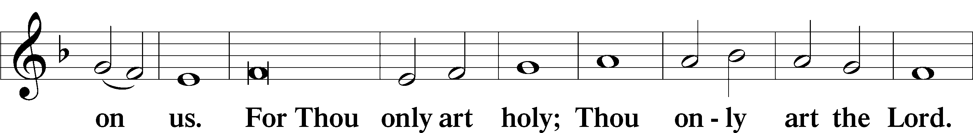
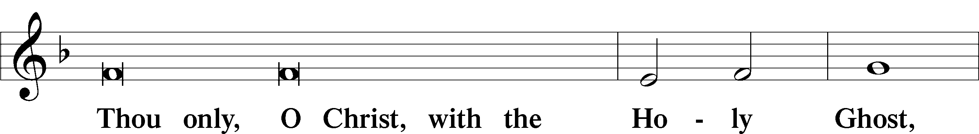
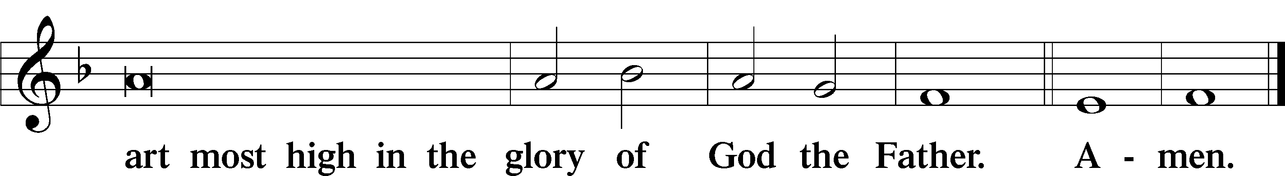

Salutation and Collect of the Day
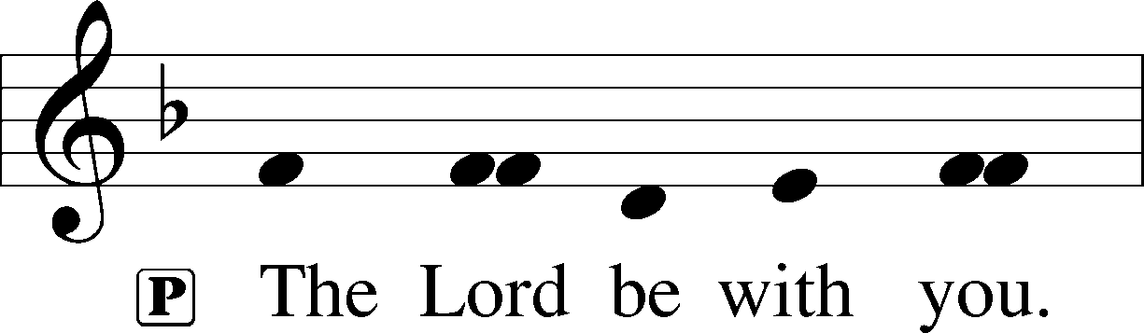
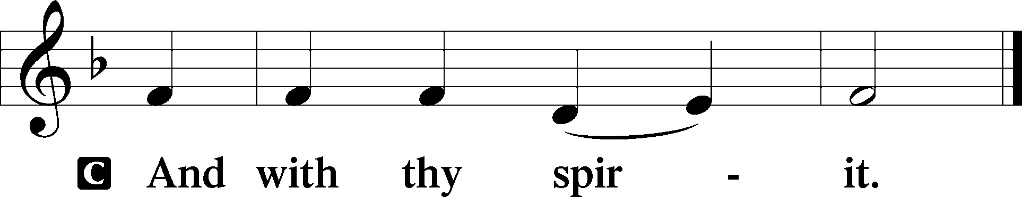

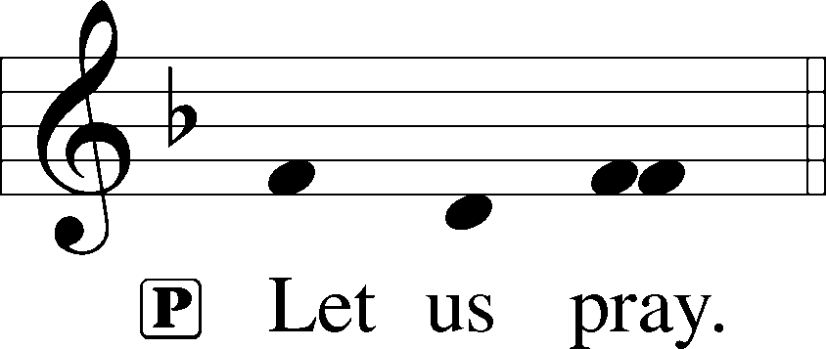

P Lord God, You made Your beloved Son, our Savior, subject to the Law and caused Him to shed His blood on our behalf. Grant us the true circumcision of the Spirit that our hearts may be made pure from all sins; through Jesus Christ, our Lord, who lives and reigns with You and the Holy Spirit, one God, now and forever.

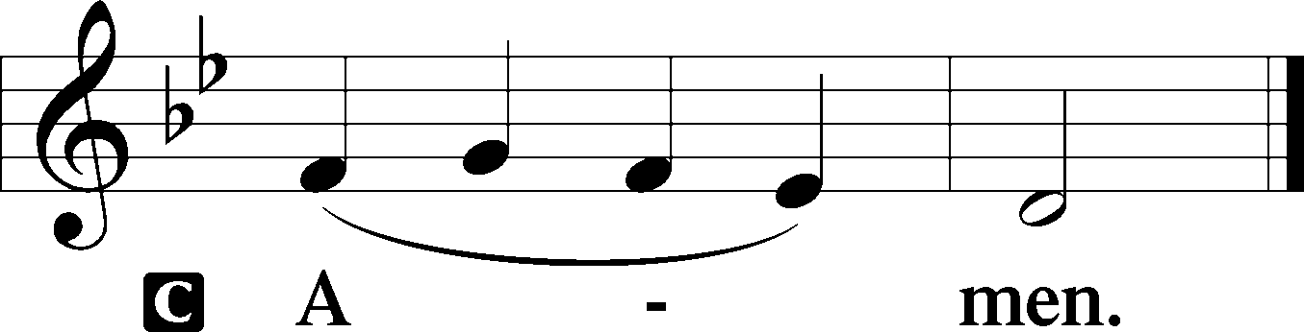

Sit

Old Testament Reading Numbers 6:22–27
The Lord spoke to Moses, saying, “Speak to Aaron and his sons, saying, Thus you shall bless the people of Israel: you shall say to them,
The Lord bless you and keep you;
the Lord make his face to shine upon you and be gracious to you;
the Lord lift up his countenance upon you and give you peace.
“So shall they put my name upon the people of Israel, and I will bless them.”

A This is the Word of the Lord.
C Thanks be to God.

Gradual Hebrews 8:10; 10:17
This is the covenant that I will make with the house of Israel
after those days, declares the Lord:
I will put my laws into their minds,
and write them on their hearts.
I will be their God, and they shall be my people.
I will remember their sins and their lawless deeds no more.

Epistle Galatians 3:23–29
Now before faith came, we were held captive under the law, imprisoned until the coming faith would be revealed. So then, the law was our guardian until Christ came, in order that we might be justified by faith. But now that faith has come, we are no longer under a guardian, for in Christ Jesus you are all sons of God, through faith. For as many of you as were baptized into Christ have put on Christ. There is neither Jew nor Greek, there is neither slave nor free, there is neither male nor female, for you are all one in Christ Jesus. And if you are Christ’s, then you are Abraham’s offspring, heirs according to promise.

A This is the Word of the Lord.
C Thanks be to God.

Stand

Alleluia LSB 190
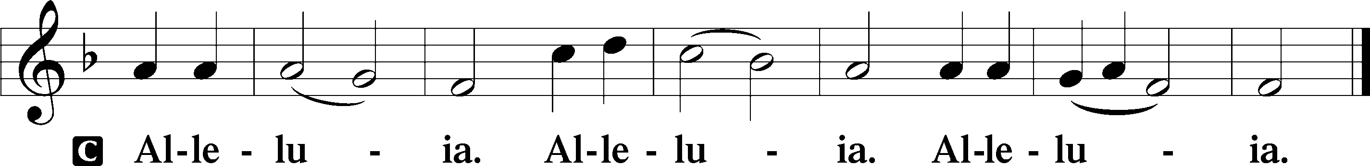

Holy Gospel Luke 2:21
P The Holy Gospel according to St. Luke, the second chapter.

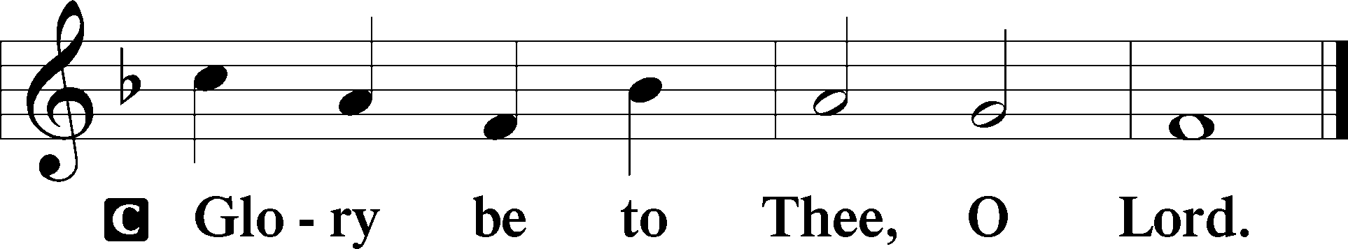

And at the end of eight days, when he was circumcised, he was called Jesus, the name given by the angel before he was conceived in the womb.

P This is the Gospel of the Lord.

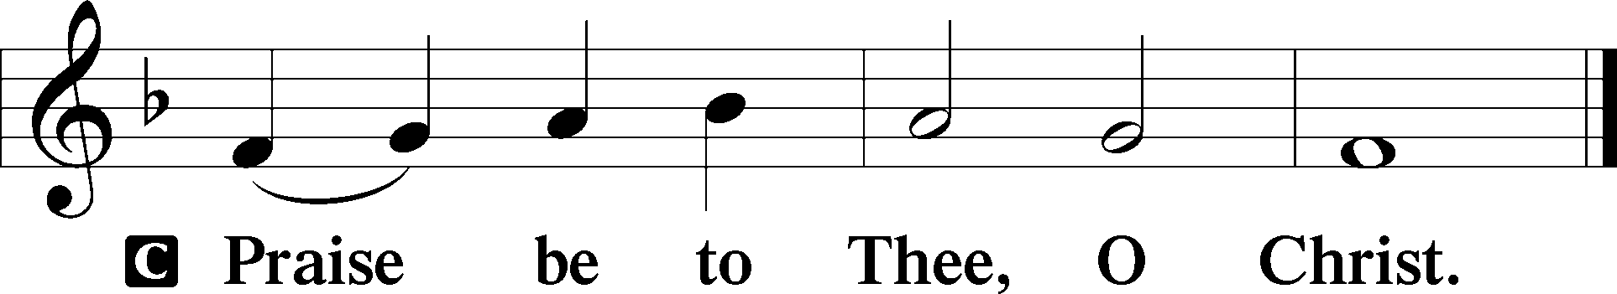

Nicene Creed
C I believe in one God,
the Father Almighty,
maker of heaven and earth
and of all things visible and invisible.

And in one Lord Jesus Christ,
the only-begotten Son of God,
begotten of His Father before all worlds,
God of God, Light of Light,
very God of very God,
begotten, not made,
being of one substance with the Father,
by whom all things were made;
who for us men and for our salvation came down from heaven
and was incarnate by the Holy Spirit of the virgin Mary
and was made man;
and was crucified also for us under Pontius Pilate.
He suffered and was buried.
And the third day He rose again according to the Scriptures
and ascended into heaven
and sits at the right hand of the Father.
And He will come again with glory to judge both the living and the dead,
whose kingdom will have no end.

And I believe in the Holy Spirit,
the Lord and giver of life,
who proceeds from the Father and the Son,
who with the Father and the Son together is worshiped and glorified,
who spoke by the prophets.
And I believe in one holy Christian and apostolic Church,
I acknowledge one Baptism for the remission of sins,
and I look for the resurrection of the dead
and the life T of the world to come. Amen.

Sit

Children’s Message

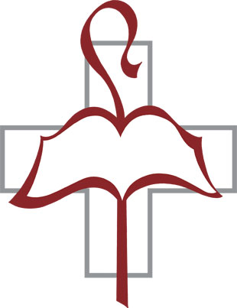
Jesus! Name of Wondrous Love LSB 900
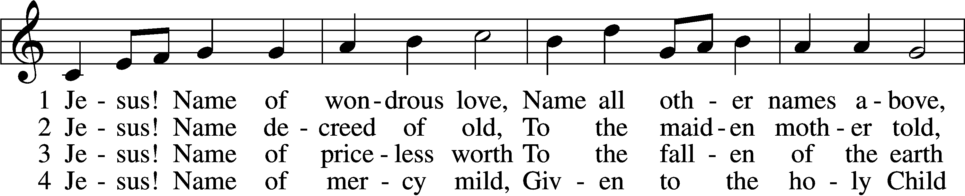
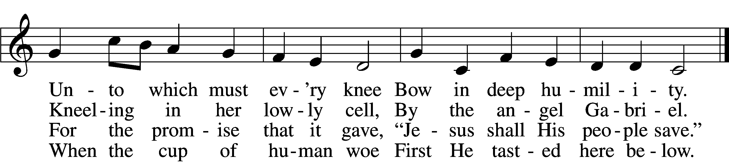

5 Jesus! Only name that’s giv’n
Under all the mighty heav’n
Whereby those to sin enslaved
Burst their fetters and are saved.

6 Jesus! Name of wondrous love,
Human name of God above;
Pleading only this, we flee
Helpless, O our God, to Thee.
Text: William W. How, 1823–97, alt.
Tune: Geist-reiches Gesang-Buch, 1704, Halle, ed. Johann A. Freylinghausen, alt.
Text and tune: Public domain

Sermon

Offering

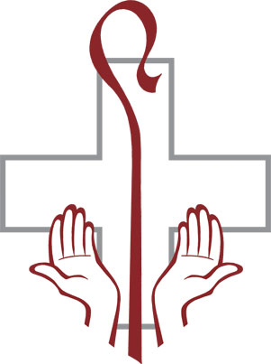
Stand

Offertory LSB 192
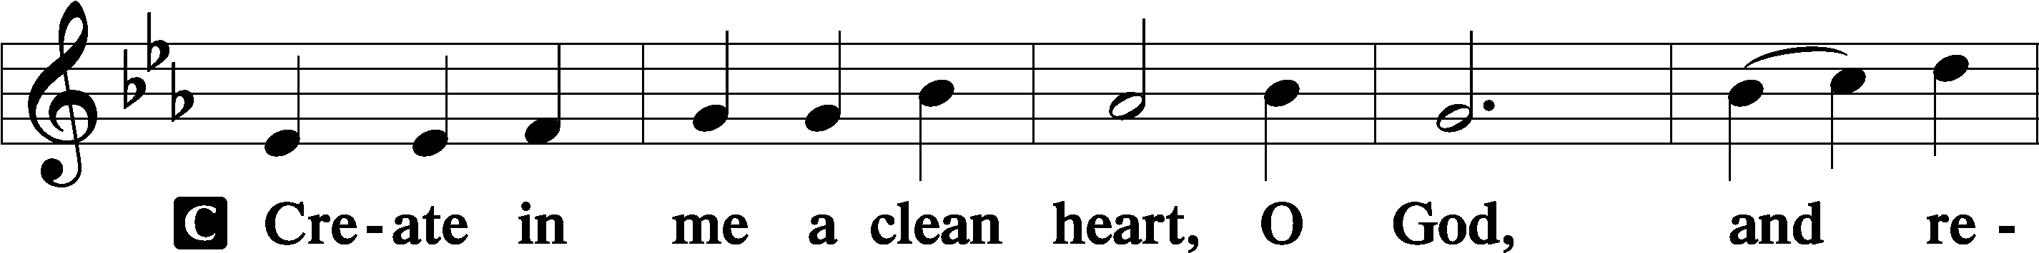
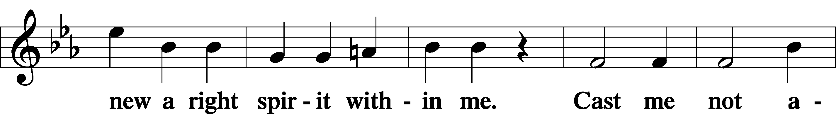
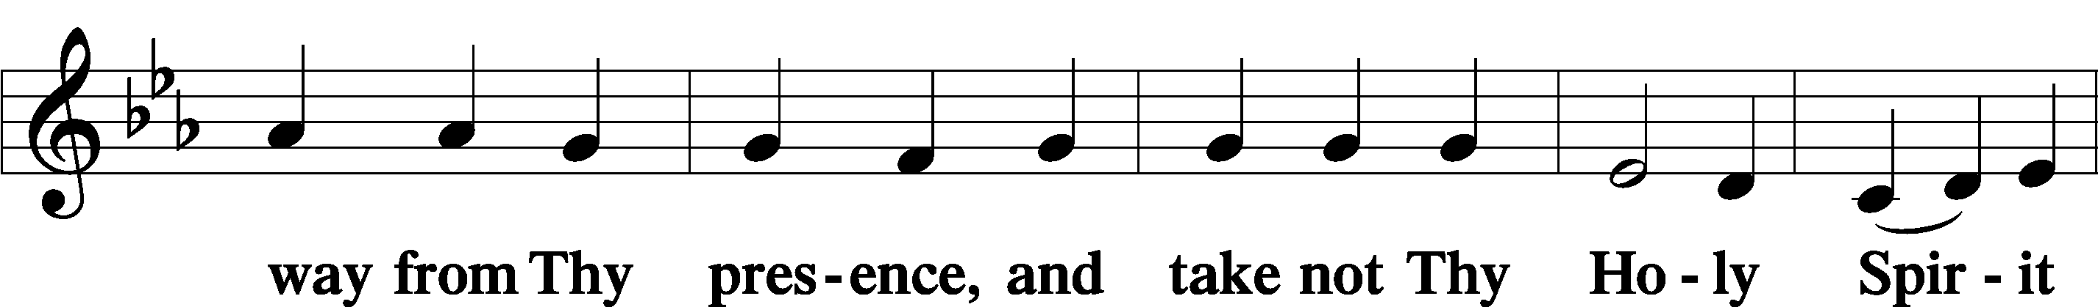
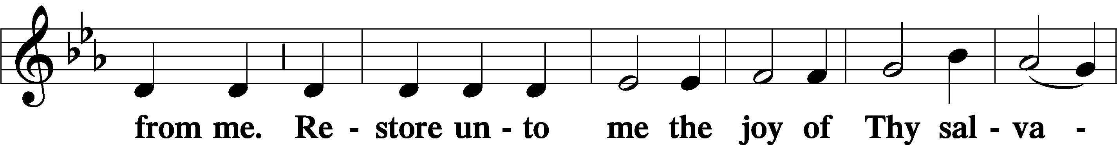
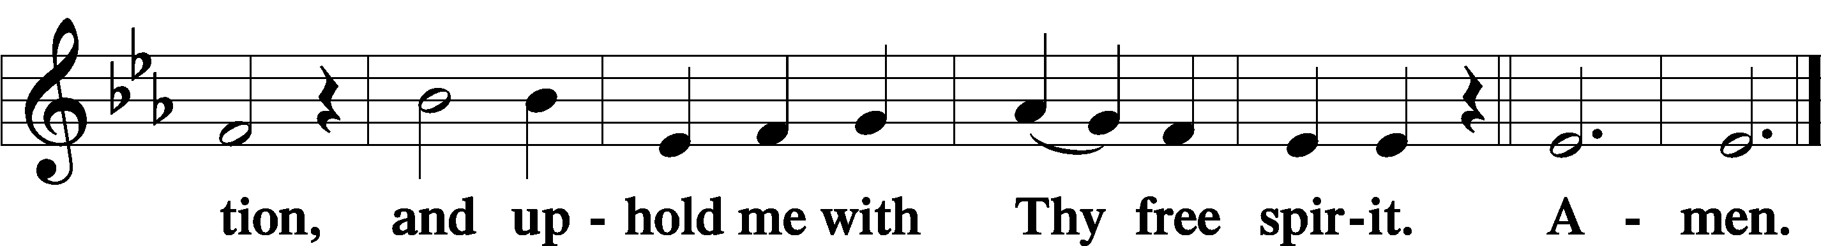

Prayer of the Church

Service of the Sacrament

Preface LSB 194
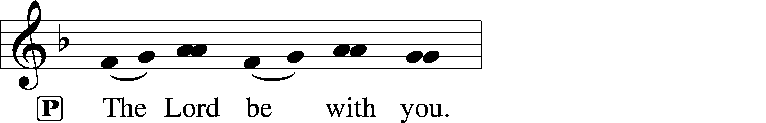
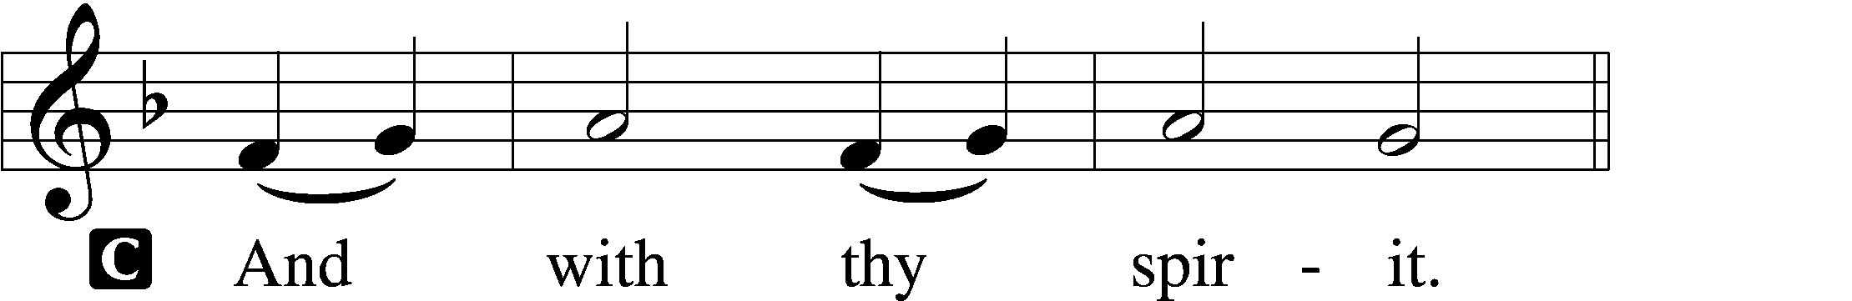

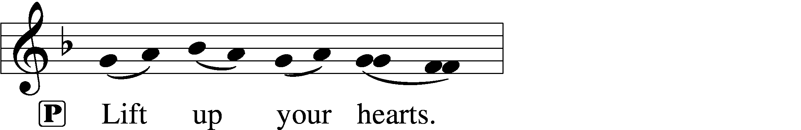
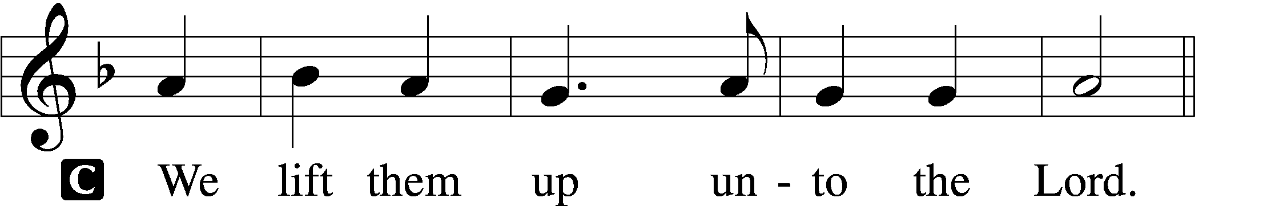

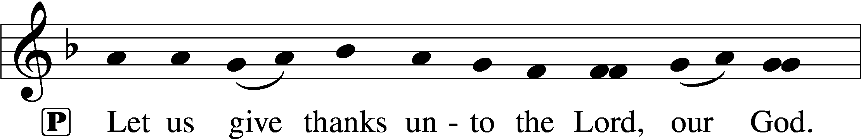
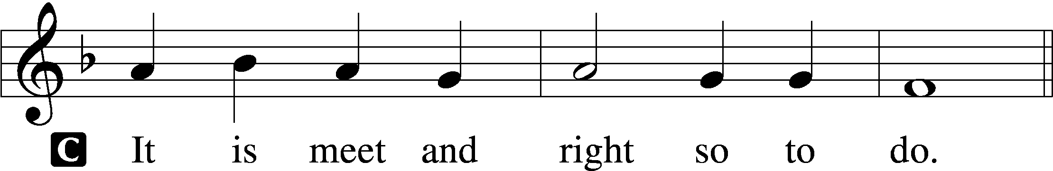

Proper Preface

Sanctus LSB 195
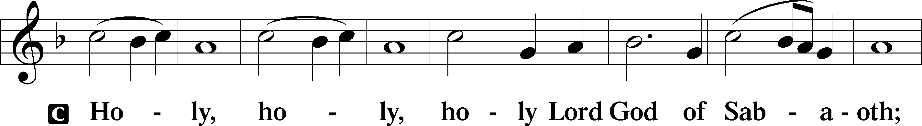
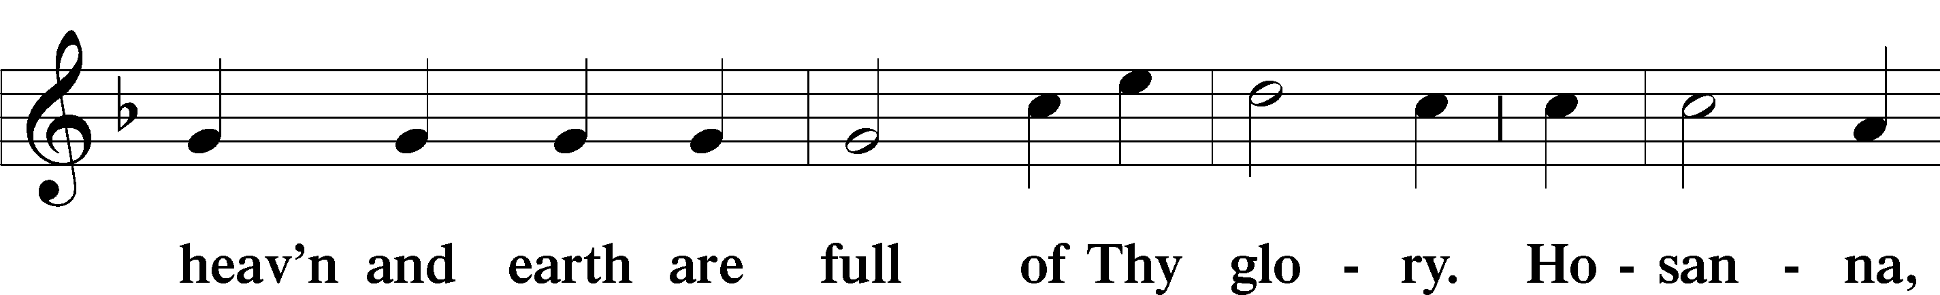
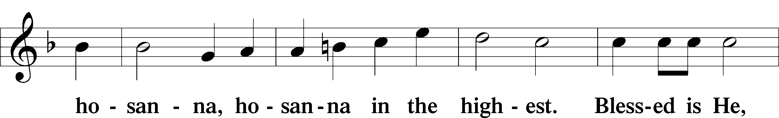
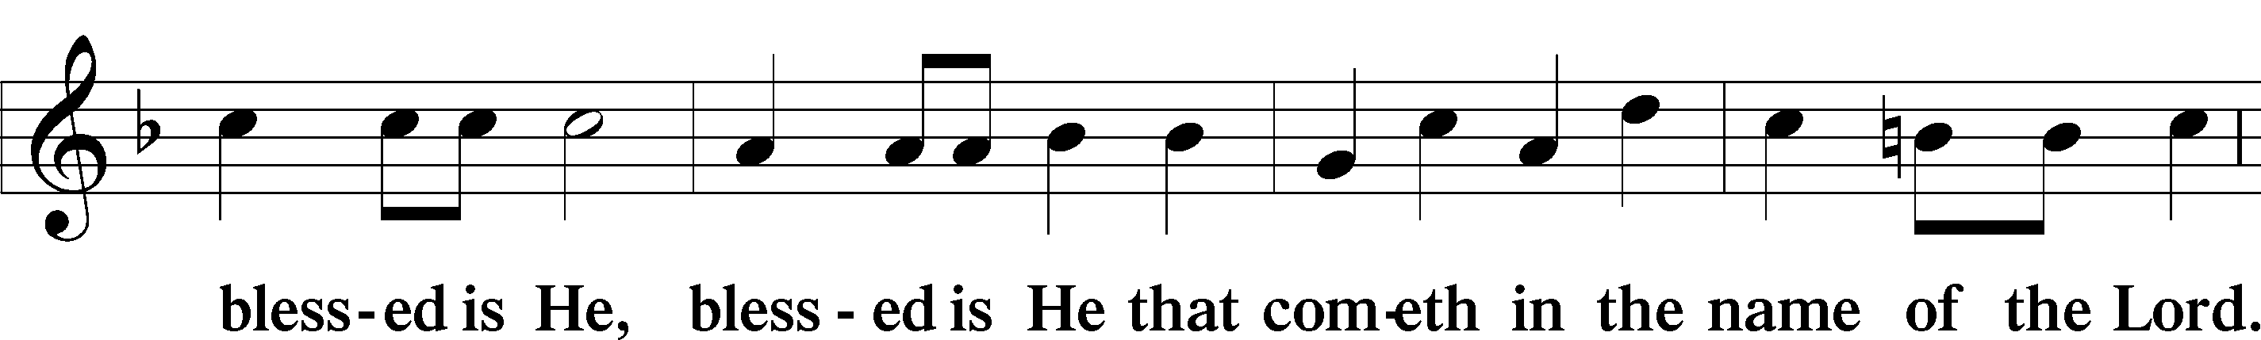
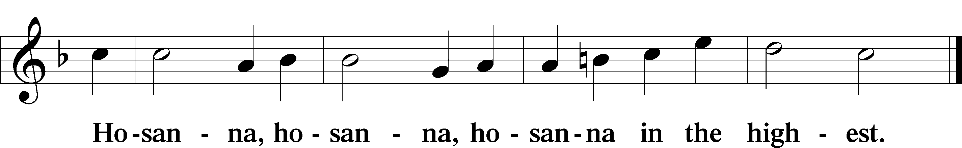

Lord’s Prayer LSB 196
C Our Father who art in heaven,
hallowed be Thy name,
Thy kingdom come,
Thy will be done on earth as it is in heaven;
give us this day our daily bread;
and forgive us our trespasses as we forgive those who trespass against us;
and lead us not into temptation,
but deliver us from evil.
For Thine is the kingdom and the power and the glory forever and ever. Amen.

The Words of Our Lord LSB 197
P Our Lord Jesus Christ, on the night when He was betrayed, took bread, and when He had given thanks, He broke it and gave it to the disciples and said: “Take, eat; this is My T body, which is given for you. This do in remembrance of Me.”

In the same way also He took the cup after supper, and when He had given thanks, He gave it to them, saying: “Drink of it, all of you; this cup is the new testament in My T blood, which is shed for you for the forgiveness of sins. This do, as often as you drink it, in remembrance of Me.”

Pax Domini LSB 197
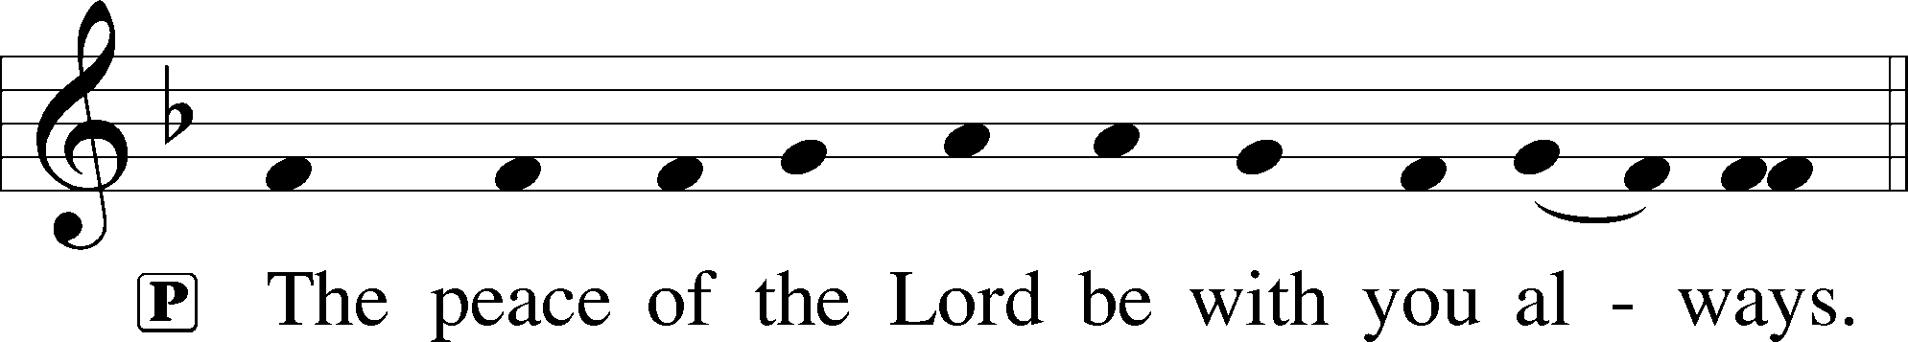

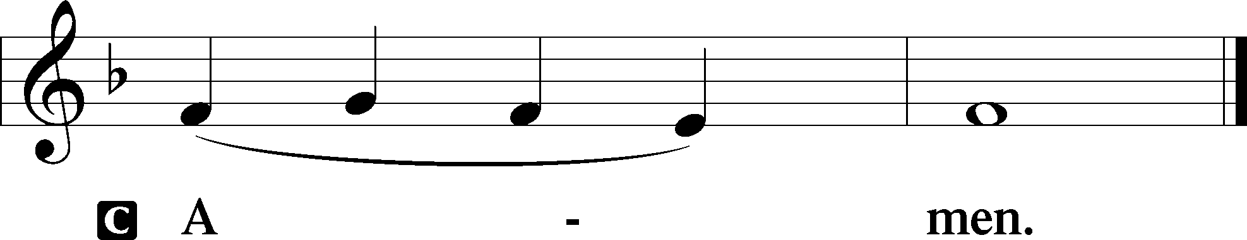
Agnus Dei LSB 198
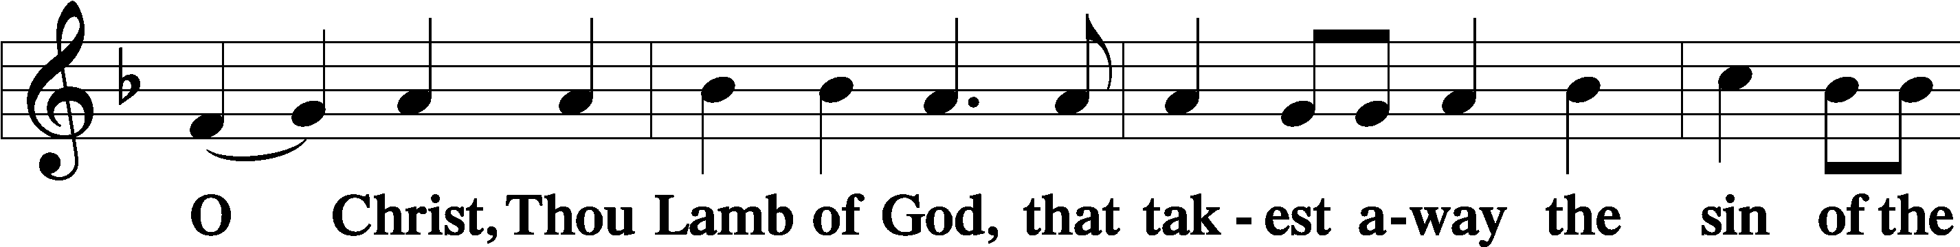
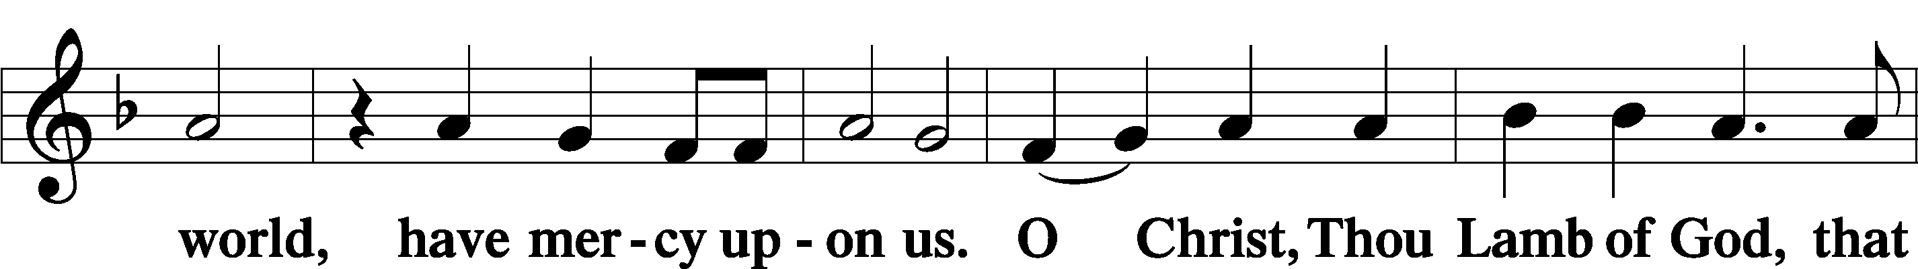
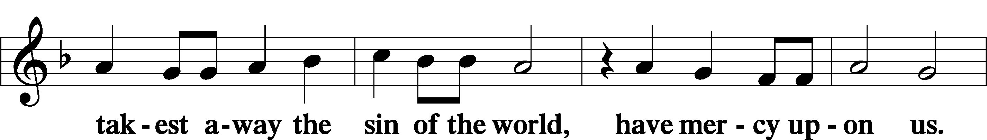
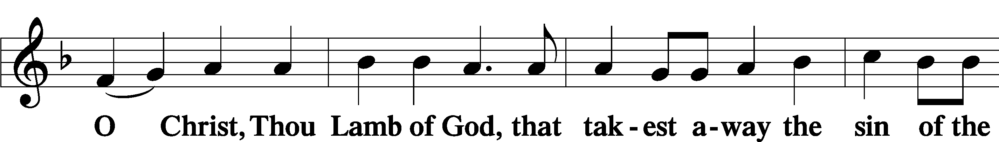
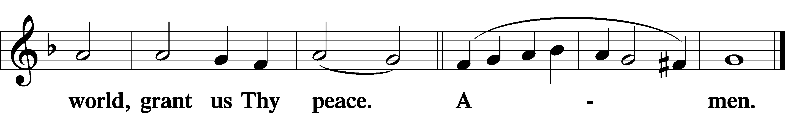

Sit

Distribution

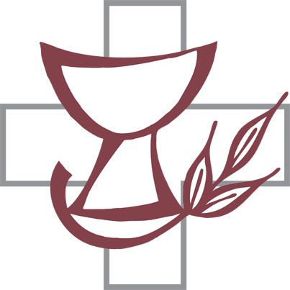
What Child Is This LSB 370
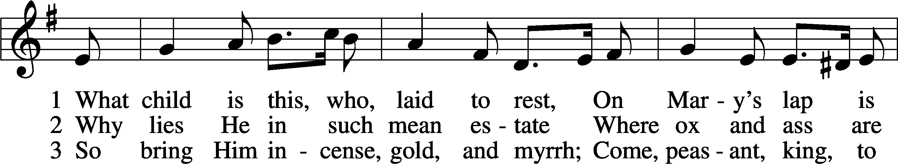
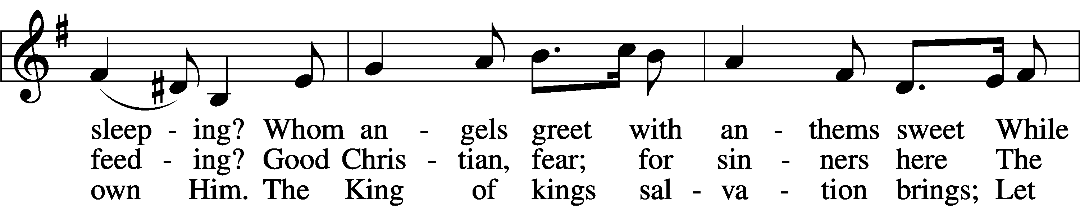
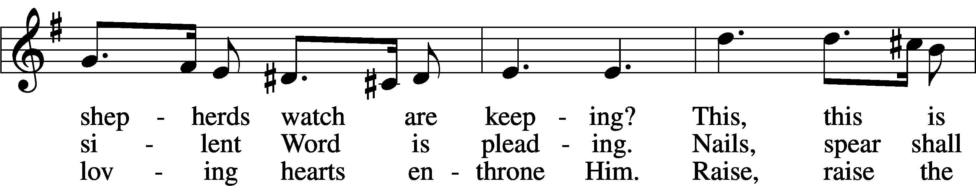
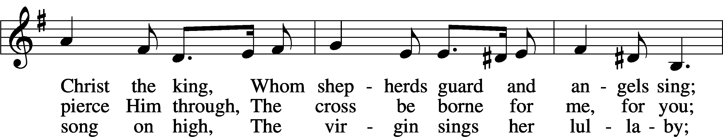
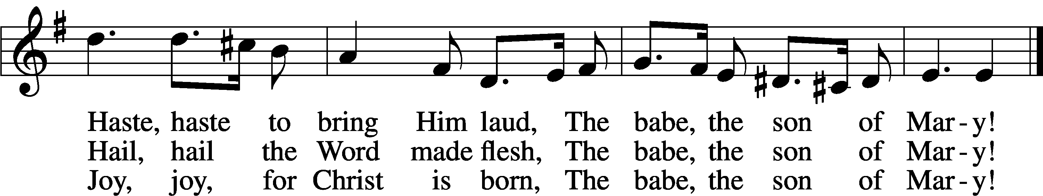
Text: William C. Dix, 1837–98
Tune: English, 16th cent.
Text and tune: Public domain

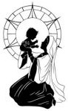

O God, Our Help in Ages Past LSB 733
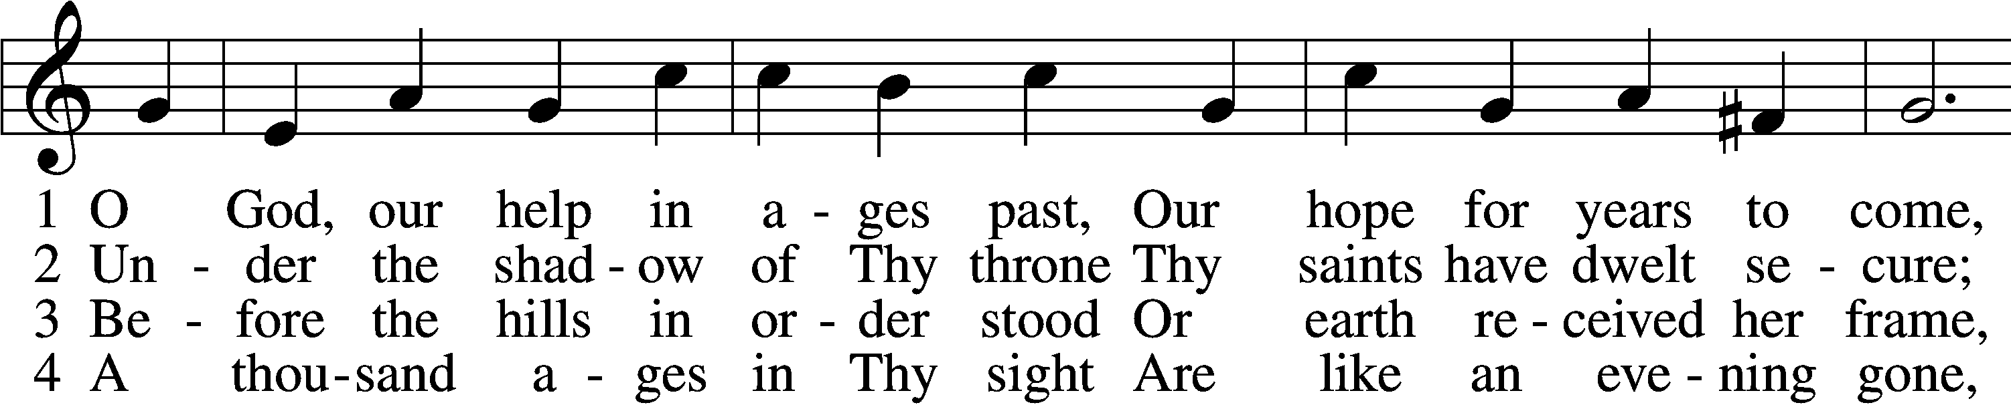
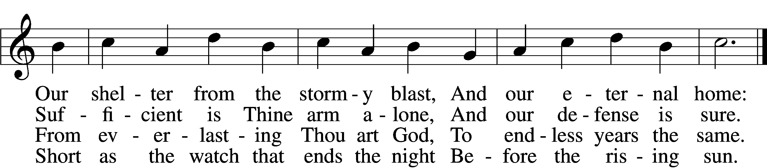

5 Time, like an ever-rolling stream,
Soon bears us all away;
We fly forgotten as a dream
Dies at the op’ning day.

6 O God, our help in ages past,
Our hope for years to come,
Be Thou our guard while troubles last
And our eternal home!
Text: Isaac Watts, 1674–1748, alt.
Tune: William Croft, 1678–1727
Text and tune: Public domain

Stand

Nunc Dimittis LSB 199
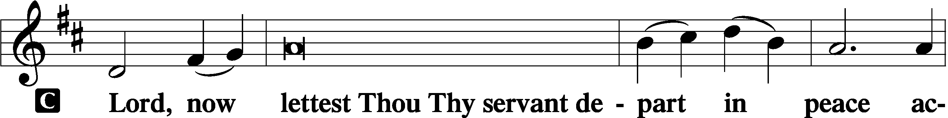

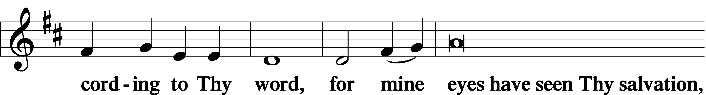

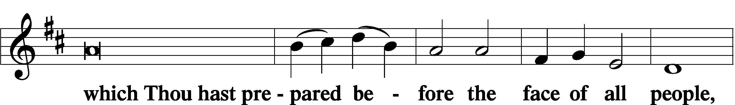

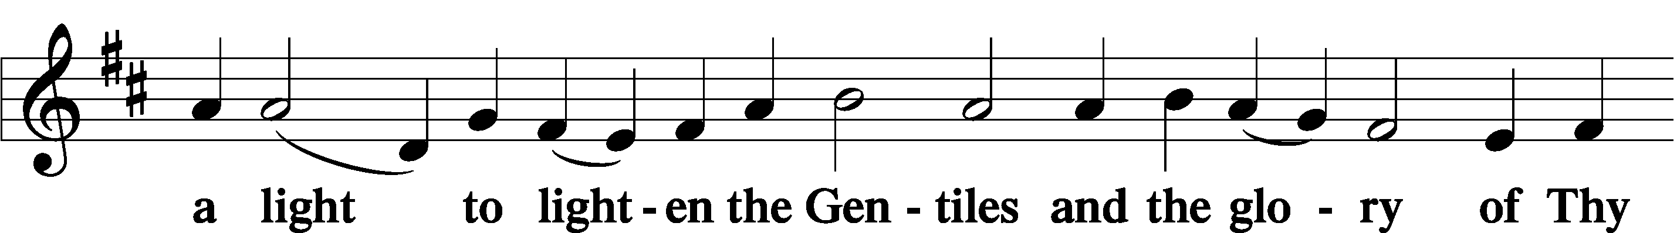

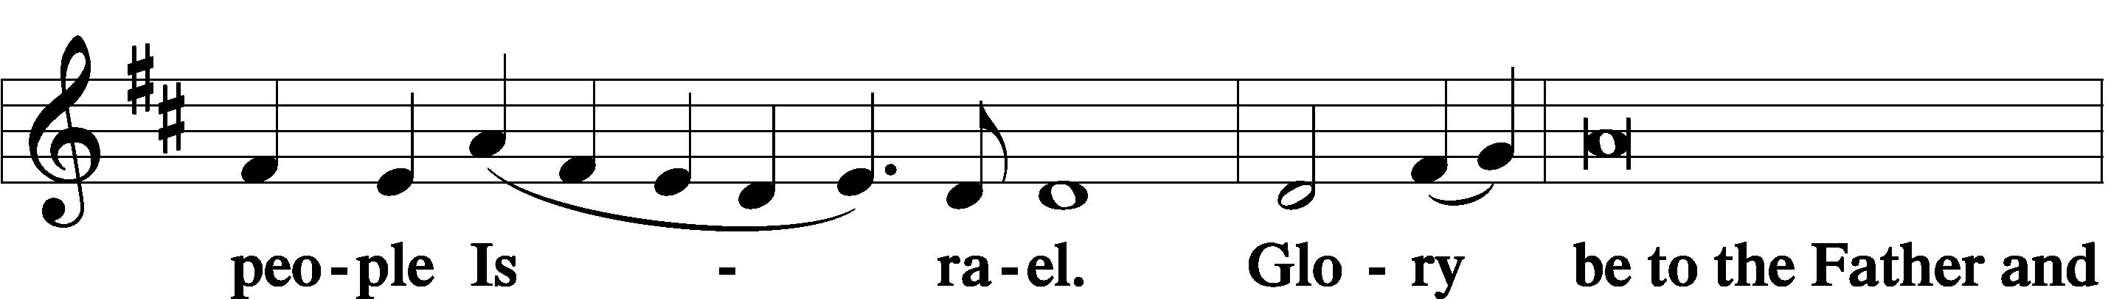

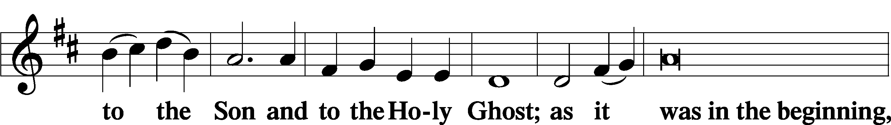

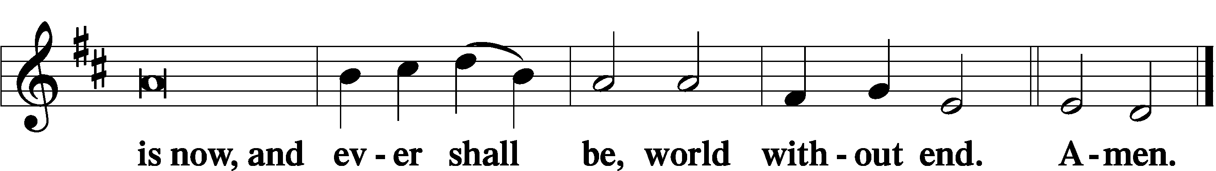

Thanksgiving LSB 200
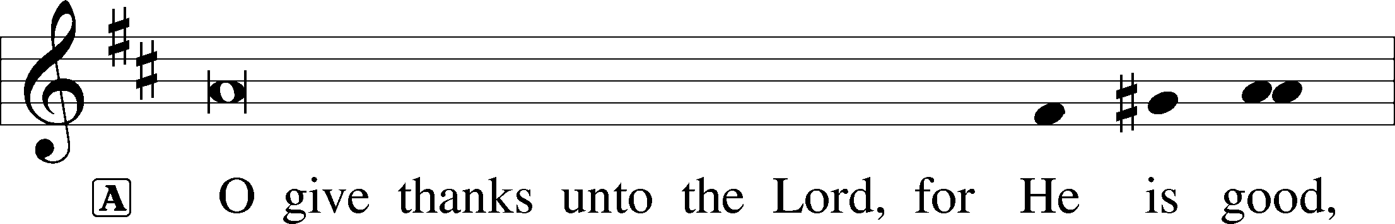

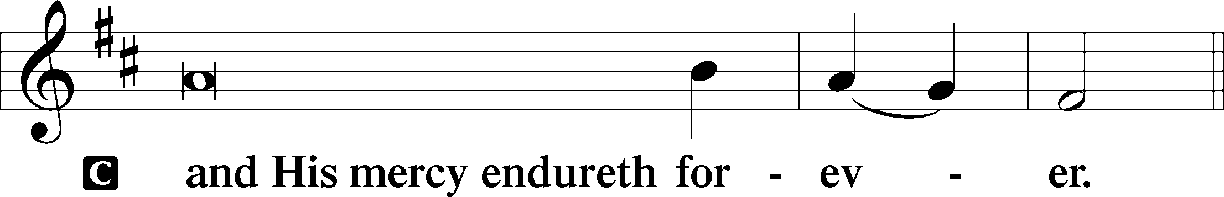

Post-Communion Collect

Salutation LSB 201
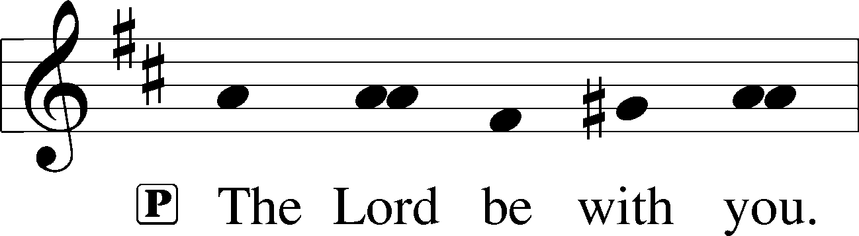

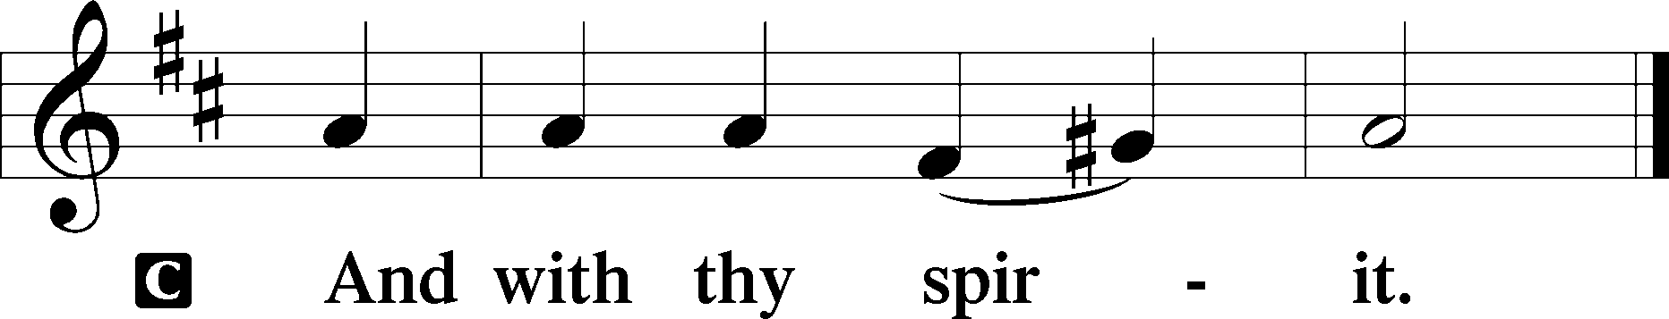

Benedicamus LSB 202
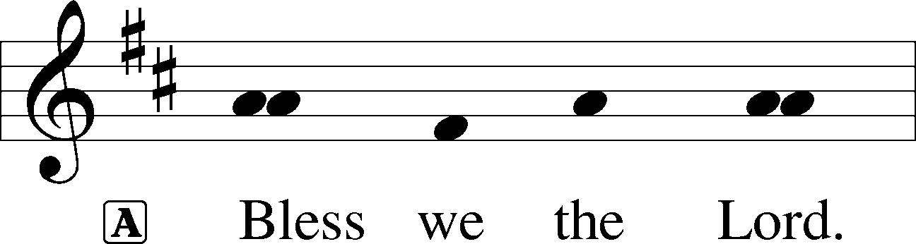

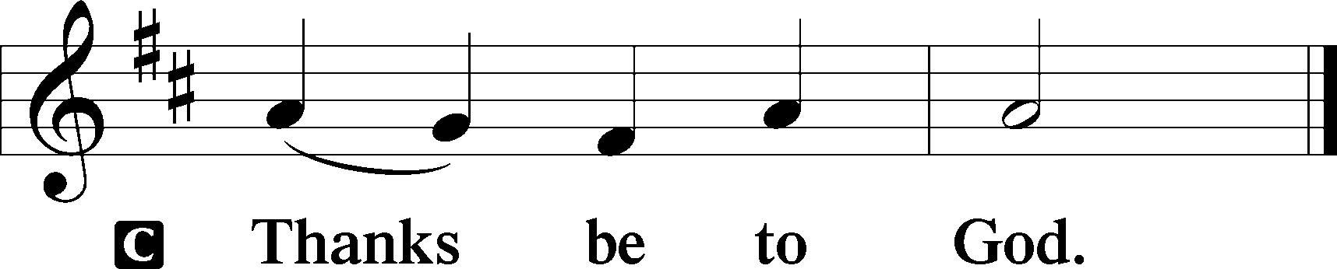

Benediction LSB 202
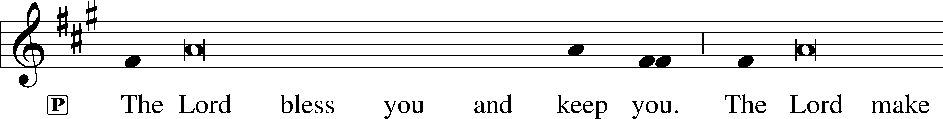
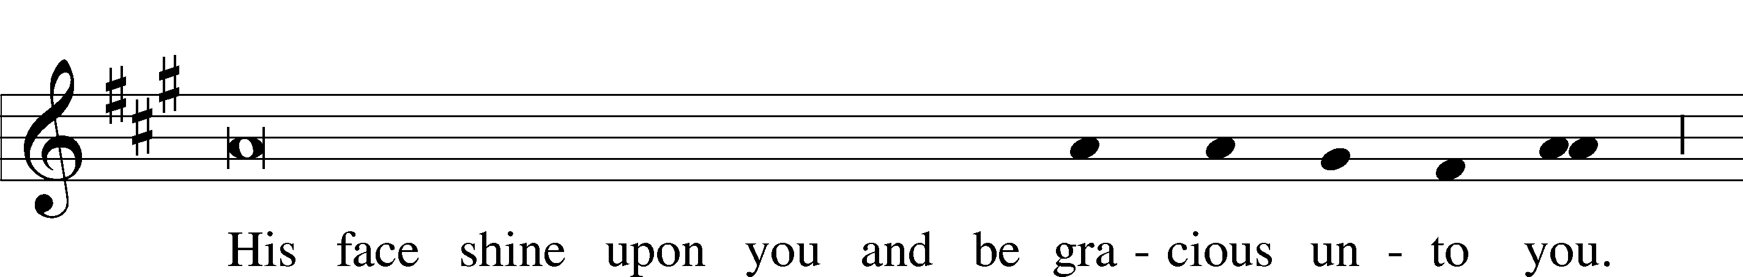
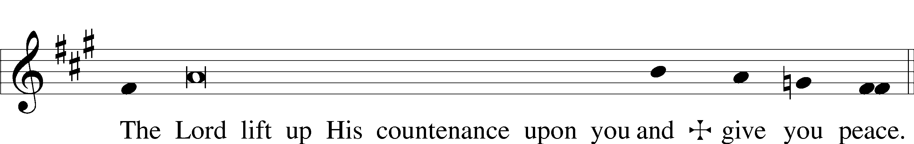

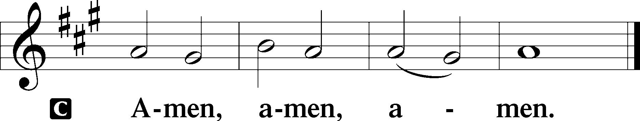

Across the Sky the Shades of Night LSB 899
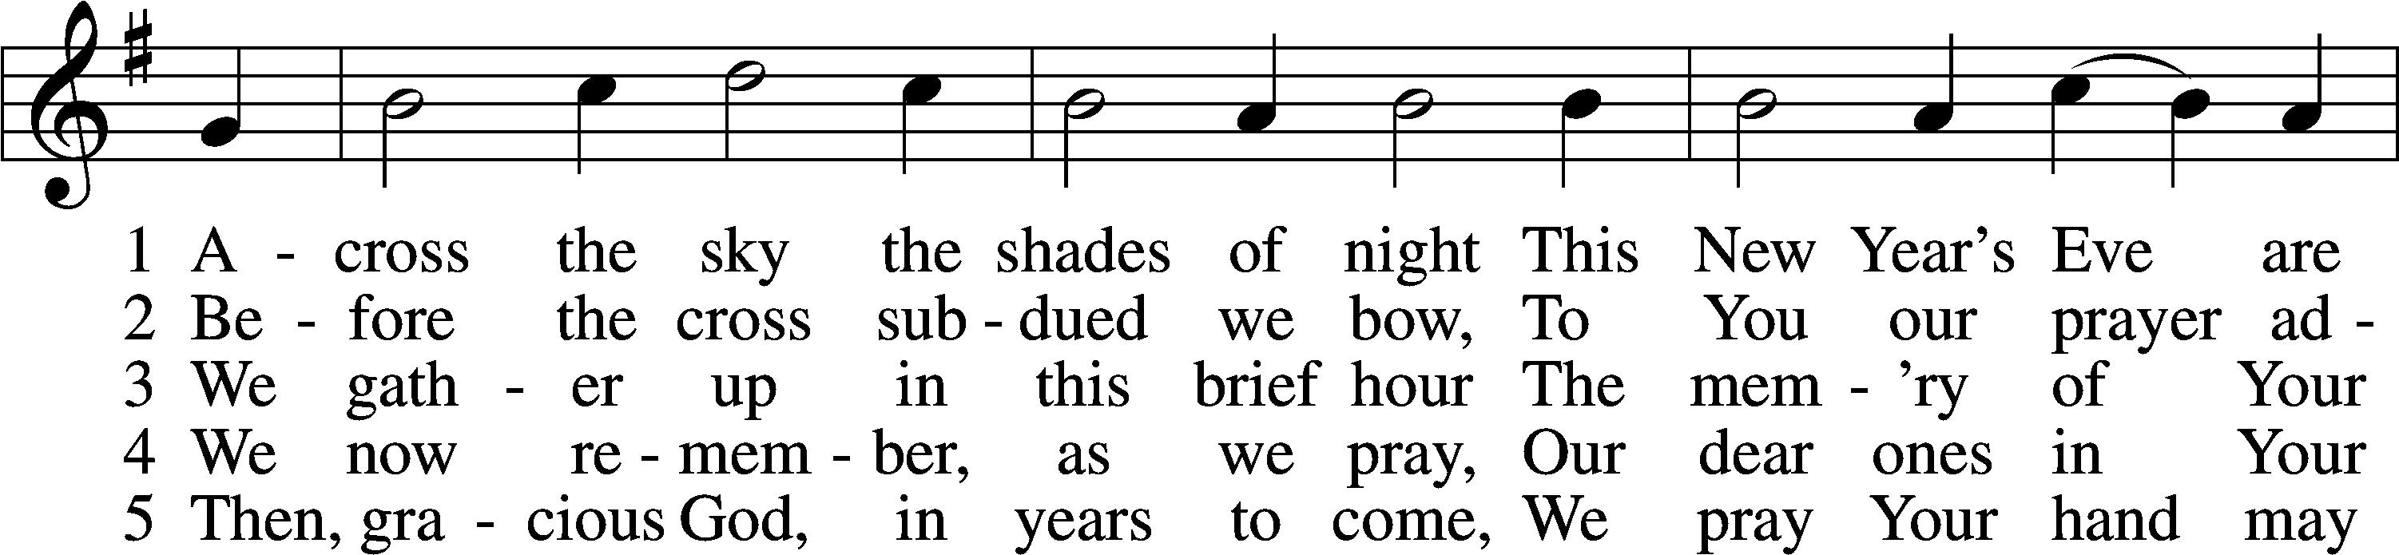
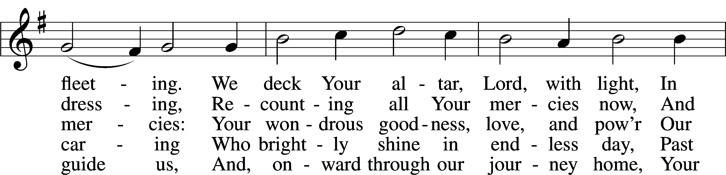
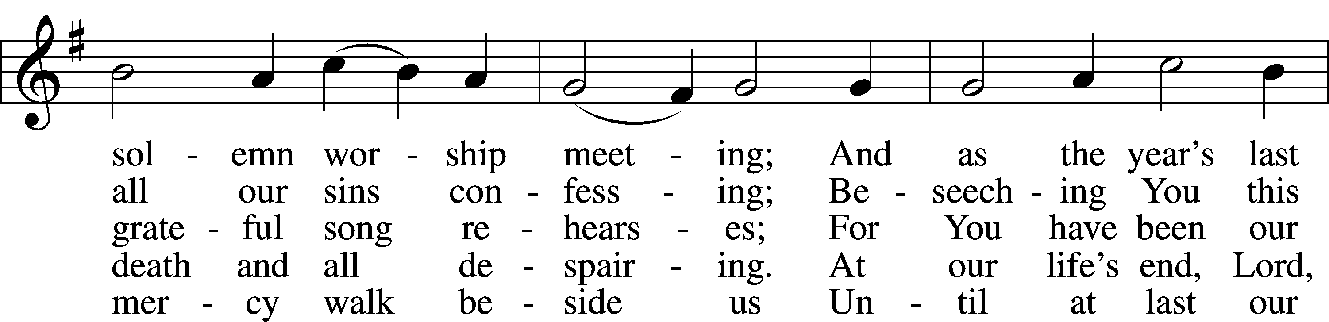
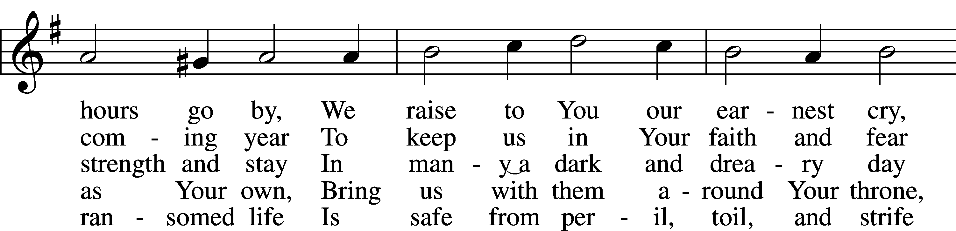
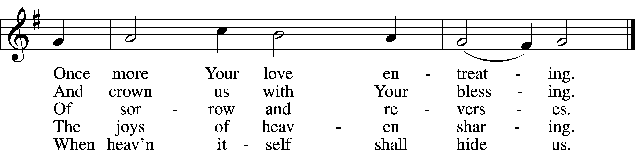
Text (sts. 1–3, 5): James Hamilton, 1819–96, alt.; (st. 4): Gregory J. Wismar, 1946
Tune: attr. Nicolaus Decius, c. 1485–after 1546
Text (sts. 1–3, 5) and tune: Public domain
Text (st. 4) and tune: © 2006 Concordia Publishing House. Used by permission: LSB Hymn License no. 110016438

Acknowledgments
Unless otherwise indicated, Scripture quotations are from the ESV® Bible (The Holy Bible, English Standard Version®), copyright © 2001 by Crossway, a publishing ministry of Good News Publishers. Used by permission. All rights reserved.
Created by Lutheran Service Builder © 2023 Concordia Publishing House.

Serving Our Lord in His House Today:
Pastor: Rev. Noah J. Rogness
Organist: Rebecca Moseley
Elder: Josh Church
TAnnouncementsT

Altar Flowers: Are placed today by the Lafferty Family in celebration of Emma’s 9th Birthday. Heavenly Father, our times are in Your hands. Look with favor on Emma as she celebrates her birthday. Grant that she may continue to grow in wisdom and grace. Strengthen her trust in your goodness and bless her with Your abiding love all the days of her life; through Christ Jesus, our Lord.

Greeter Opportunity: A new Greeter Sign-up Sheet is on the easel in the Narthex. "Serve the Lord with gladness." (Ps.100:2a) Be the friendly, welcoming face at the door on Sundays! If you have questions, contact Sylvia Engel.

Epiphany Bonfire: Join us for an Epiphany Bonfire. Activities will start at 3pm on Saturday, January 6th at the church. Bring a board game for indoor fellowship, join us for pizza, and bring your real tree/wreath for the bonfire. There is a sign up on the easel in the Narthex.

2024 Offering Envelopes: Offering envelopes have been placed in your mailbox. If you did not receive a box, and would like envelopes, please contact Deb Lafferty in the church office.

LWML Meeting: Good Shepherd Women/LWML will be having their first meeting of the new year on January 2nd at 4:45 pm with the meeting starting at 5pm. We need some new members with fresh ideas, so all Ladies are invited to attend. Hopefully, we will see you there.

SCRIP Orders: Scrip orders are due in the office by Sunday, January 14th. Order forms are in the entry way in the pamphlet rack. If you have questions feel free to talk with Kathy Berg about the process.

Our Week With Our Lord:
Today; 12/31 9:00am Divine Service
*No Adult Bible Study or Sunday School
Monday; 1/1 New Year’s Day- Office Closed
Tuesday; 1/2 4:45pm LWML Meeting
Wednesday; 1/3 6:00pm Confirmation Class
7:00pm Divine Service
Saturday; 1/6 3:00pm Epiphany Bonfire, pizza & Fellowship @church
The Epiphany of Our Lord
Sunday; 1/7 9:00am Divine Service
Adult Bible Study & Sunday School

